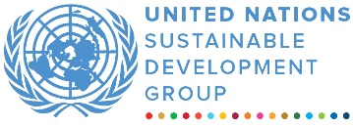
Productive Sectors Development Programme
MPTF OFfice GENERIC final programme NARRATIVE report
REPORTING PERIOD: from July 2020 to December 2023

Programme Title & Project Number |  |  | Country, Locality(s), Priority Area(s) / Strategic Results
- Programme Title: Productive Sectors Development Programme  - Programme Number 00122996  - MPTF Office Project Reference Number: 00122996 |  |  | Country/Region Lebanon
 |  |  | Priority area/ strategic results: Support gender-responsive job creation and economic opportunities in the agriculture and agro-food sectors, prioritizing women and female youth in disadvantaged areas.
Participating Organization(s) |  |  | Implementing Partners
- UNIDO, FAO, UNDP, ILO, UN WOMEN, and UNICEF |  |  | - National counterparts (government, private, NGOs & others) and other International Organizations
Programme/Project Cost (US$) |  |  | Programme Duration
Total approved budget as per project document:  MPTF /JP Contribution: 7,410,611 |  |  | Overall Duration (months) 42  Start Date (20.07.2020)
 |  |  | Original End Date (31.07.2023)
Actual End date(31.12.2023)

Have agency(ies) operationally closed the Programme in its(their) system?
Yes
 |  |  | Expected Financial Closure date:
TOTAL: USD 7,410,611 |  |  | 31.12.2024
Programme Assessment/Review/Mid-Term Eval. |  |  | Report Submitted By
Evaluation Completed  Yes No Date: 12.07.2024  Evaluation Report - Attached  Yes No Date: 12.07.2024 |  |  | - Name: Rony Gedeon  - Title: Partnership and finance Officer  - Participating Organizations: UNIDO, FAO, UNDP, ILO, UN WOMEN, and UNICEF  - Email address: rony.gedeon@un.org

ACRONYMS
ALI | Association of Lebanese Industrialists
CCIAT | Chamber of Commerce, Industry, Agriculture of Tripoli and North Lebanon
CSOs | Civil Society Organizations
B2B | Business-to-Business
ESCWA | Economic and Social Commission for Western Asia
EU | European Union
FAO | Food and Agriculture Organization of the UN
FFS | Farmers Field Schools
GAP | Good Agricultural Practices
ICM | Integrated Crop Management
IDAL | Investment Development Authority of Lebanon
IDRAC | Industrial Development and Research Agro-Agri Center
ILO | International Labor Organization
IPM | Integrated Pest Management
JP | Joint Programme
LEA | Lebanon Export Academy
LCRP | Lebanon Crisis Response Plan
LLWB | Lebanese League of Women in Business
MFIs | Micro Finance Institutions
MoA | Ministry of Agriculture
MoET | Ministry of Economy and Trade
MoI | Ministry of Industry
MSMEs | Micro, Small and Medium Enterprises
OSH | Occupational Safety and Health
PPP | Public-Private Partnership
PSDP | Productive Sector Development Programme
PSEA | Prevention of Sexual Exploitation and Abuse
PUNOs | Participating United Nations Organizations
RCO | Resident Coordinator’s Office
SC | Steering Committee
SDG | Sustainable Development Goal
SMEs | Small and Medium Enterprises
ToT | Training of Trainers
UN | United Nations
UN Women | United Nations Entity for Gender Equality and the Empowerment of Women
UNDP | United Nations Development Programme
UNICEF | United Nations Children’s Fund
UNIDO | United Nations Industrial Development Organization
WDB | Women Do Business
WEPs | Women’s Empowerment Principles

Contents

Executive Summary 4
Purpose 5
Assessment of Programme Results 8
Outcome 1: The MACRO component 8
i. Legislative and policy review 8
ii. Roundtable and one-on-one consultations 9
iii. The gender audit 10
iv. Gender analyses 11
v. MACRO Key Results 11
Outcome 2: The MESO component 12
i. Improving government capacities to promote exports 12
ii. Developing tailored capacity building programme on export readiness 12
iii. Providing network opportunities (National and international levels) 13
iv. Providing tailored support coupled with financial provision 13
v. MESO Key Results 15
Outcome 3: The MICRO component 16
Package 1: Technological advancement 18
Package 2: Soft skills development 18
Package 3: Extension and advisory services to GAP and safer produce 21
Package 4: Gender Sensitivity business development support and entrepreneurship training 23
Package 5: Institutional support 26
Package 6: Direct market access activities (National & International levels) 28
MICRO Key Results 30
Indicator based performance assessment 31
Evaluation, best practices and lessons learned 47
i. Challenges faced during the implementation 47
ii. Key lessons learned and best practices and recommendations 49

FINAL PROGRAMME REPORT FORMAT

Executive Summary

In July 2020, the Productive Sectors Development Programme (PSDP), a UN joint programme was initiated in support of gender-responsive job creation and economic opportunities in the agriculture and agro-food sectors. The programme placed a specific emphasis on prioritizing women and female youth in disadvantages areas.
The PSDP was jointly implemented by UNIDO, FAO, UNDP, ILO, UN Women, and UNICEF and it included interventions on three levels: the macro (national policy), meso (institutional), and micro (direct beneficiary support) levels. These building blocks tackled a range of challenges to maximize the impact of the programme on focus sectors and communities, support gender-responsive job creation especially for women and female youth and promote inclusive and long-term economic growth.

The PSDP included interlinked activities, forming a cohesive package and supported 284 Lebanese MSMEs and start-ups (76% women-led), 406 farmers (61% are female), 644 Individuals (76% are female) and 1243 vulnerable youth (79% women) and women by focusing on their main challenges faced in the selected sectors, including poor policy environment, difficulties in accessing national and international markets, poor infrastructure, high cost of production, shortage of skills, amongst others.
The "Delivering as One" initiative among the six implementing UN agencies exemplified a collaborative approach by bringing together different areas of expertise for a more effective and integrated implementation of the programme objectives.

In terms of employment, the programme contributed to supporting jobs both directly and indirectly. Until today 1117 jobs were created (among which, 78% (873) are female – 22% (244) are male and 1% with disabilities) and 1344 jobs were sustained (among which, 60% (801) are female and 40% (543) are male). Notably, 49% (out of 77) of female youth have been placed in employment as a result of work-based learning initiatives. Given the nature of the programme scope and activities, the impact is expected to continue after the programme end date and to materialize more concretely in the next 12-18 months.

Purpose

The programme aimed to harness the collective expertise of the PUNOs to implement initiatives on the macro, meso and micro levels while focusing on value chains that have high potential for growth and highest job generation potential for women:

- On the MACRO level the PSDP worked on improving the macro factors affecting the status of women in the agriculture and agro-food sectors. This level involved addressing systemic challenges through legislative and policy review, roundtable and on-one-on consultations, gender audit and gender analysis.

- On the MESO level the PSDP partnered with line government counterparts and the private sector to enhance the overall market access for MSMEs. This level included improving government capacities to promote exports, developing tailored capacity building programme on export readiness and providing network opportunities and tailored support coupled with financial provision.

- On the MICRO level, the PSDP adopted an area-based approach to enhance the competitiveness of the selected value chain “Fruits, vegetables, nuts and pulses” in Northern Lebanon through 6 integrated packages. This level, involved collaboration from six UN agencies, each bringing its area of expertise to contribute to the development of the selected value chain.

The combined top-down (macro and meso) and bottom-up (micro) approaches were crucial, adding value to the different components of the PSDP.

In addition, interlinkages across three levels - MACRO, MESO, and MICRO (as per below graph) - within the PSDP focused on gender mainstreaming and support for SMEs, farmers and start-ups:

- At the MACRO level, gender analysis conducted helped in aligning activities with the needs of women farmers and women-led MSMEs and to tailor the PSEA training which was disseminated among all PSDP actors. Consultations and policy reviews facilitated discussion and engagement among stakeholders, enhancing coordination and inclusivity.

- At the MESO level, training MSMEs receiving different types of technical support from the MICRO level on export readiness and providing them with market access opportunities formed a comprehensive package of support.

- Interlinkages among the MICRO level involved various support initiatives for MSMEs, start-ups, farmers women and youth. Coordination efforts between local partners and PUNOs facilitated beneficiary engagement. Initiatives like linking farmers with SMEs for input provision and technical training/coaching for women-led SMEs and start-ups demonstrated interagency collaboration, as such:
- Farmers were linked with SMEs for input provision.
- Farmers and SMEs and start-up benefited from diverse testing, agriculture and ago-food services provided by IDRAC.
- Referrals facilitated access of MSMEs to technical training, equipment provision, and solar systems. Similarly, startups and vulnerable women benefited from comprehensive business. empowerment, technical equipment, solar provision and national and internal market access support.
- Technical skills training in agro-food processing benefited beneficiaries including farmers, women, SMEs, and startups from almost all PUNOs collaboration.
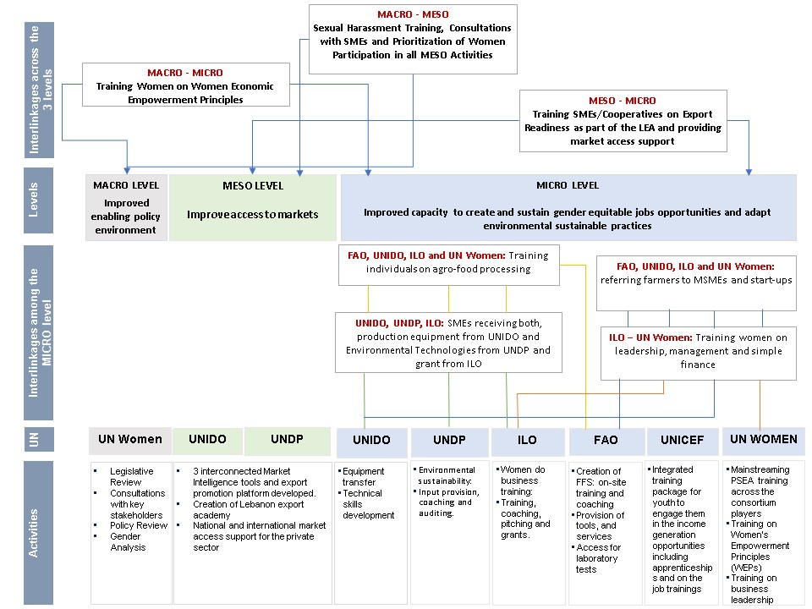
The programme was implemented in close coordination with the relevant government counterparts and partners, including the Ministry of Economy and Trade, Ministry of Industry, Ministry of Agriculture, IDAL, Berytech, IDRAC and the Chamber of Commerce, Industry, Agriculture of Tripoli and North Lebanon.
The PSDP falls within the Prosperity pillar of the United Nations Sustainable Development Cooperation Framework Strategic Framework (2023-2025) complementing other UN interventions in Lebanon which aims to improve resilient and competitive productive sectors for enhanced and inclusive income-generating and livelihood opportunities.

It also contributed to the objectives and outcomes of multiple national strategies and priorities including:

- National government priorities set in the 2020 Economic Recovery plan mainly “the creation of economic values and productive sectors” by strengthening the agri-food sector value chain through supporting the quality and competitiveness of several key products that Lebanon has a competitive edge in, thus contributing to the long-term sustainability of the sector
- Government of Lebanon strategy for the agricultural sector established by the Ministry of Agriculture (MoA) in the National Agricultural Strategy for the period 2020–2026, namely in three of its pillars:
- Pillar 1: Restoring the livelihoods and productive capacities of farmers and producers
- Pillar 2: Increasing agricultural production and productivity
- Pillar 3: Enhancing the efficiency and competitiveness of agri-food value chains

- “The foundational gender sensitivity of the National Agricultural Strategy”: NAS aims to achieve equality between women and men in sustainable agricultural production and rural development.”

- The Ministry of Industry integrated and complete vision for the industrial sector and its strategic plans (Ministry of Industry’s Vision 2025).

The project had direct and indirect contributions to a number of SDGs. Placing SDG 5 to achieve gender equality and empower all women and girls at its center, the PSDP directly contributed to SDG 9 to build resilient infrastructure, promote inclusive and sustainable industrialization and foster innovation, SDG 10 to reduce overall inequality and SDG 8 to support decent work and economic growth. It also supported a number of other SDGs by addressing poverty reduction (SDG 1: No Poverty and SDG 2: No Hunger) and working in partnerships to achieve desired goals (SDG 17).

Assessment of Programme Results

Outcome 1: The MACRO component

The PSDP applied a multi-layered approach and a set benchmarks for gender equality by addressing emerging issues and aligning with the goal of empowering women as critical agents of change in the 2030 Agenda.

The approach involved a top-down strategy while addressing the following:

i. Legislative and policy review

Involved two major components: mapping direct and indirect discrimination within 10 legislative frameworks relevant to women's rights in the workplace and examining women working conditions in different workplaces such as factories, retail shops, cooperatives, facilities, services, microfinance institutions and extension services. As a result, gaps were identified in 10 legislations and 7 priorities were shortlisted, which are:
- Including in the Labor Law a definition of discrimination as adopted by the Committee on Economic, Social and Cultural Rights as “any discrimination in the possibility of obtaining and maintaining a job because of: race, color, sex, language, religion, political or other opinion, national or social origin, or wealth, parentage, physical or mental disability, health conditions including HIV infection, sexual orientation, civil, political, social or other status, intended to undermine or nullify the exercise of the right to work on the basis of equality, or have this effect.”
- Amending Article 50 of the Labor Law related to arbitrary dismissal from work in terms of increasing the compensation that can be awarded in the event of arbitrary dismissal, in addition to expanding the reasons for dismissal to include any discrimination on the basis of sex.
- Adoption of a law that regulates work related to agriculture, supports rural women farmers, and takes into account the special needs of agricultural workers with regard to pregnancy, breastfeeding and reproductive health.
- Adopting a legal framework to include women farmers within the range of groups benefiting from the protection of the Labor Law; As agricultural workers were excluded from the provisions of the law. Therefore, it is necessary to amend the Labor Law (particularly Articles 5 and 7), in addition to a comprehensive review and the inclusion of specific provisions to regulate work in the agricultural sector. Similarly, expanding the scope of work of the Social Security Corporation to provide social protection for all categories of workers, including female labor in agriculture.
- Cancellation of Article 14 of the Trade Law, which states the following: The rights of a married woman are determined, when necessary, by the provisions of her personal law and her marital contract.
- Cancellation of Article 58 of Implementation Decree No. 2989 issued on March 17, 1972, in which the right of a man to vote in place of a woman in cooperative elections is abolished, and so that a woman represents herself without an agent or mediator.
- Financial services, including credits and loans, include gender-sensitive mechanisms and are not withheld from rural women due to the lack of a male guarantor.

ii. Roundtable and one-on-one consultations

Ensured a multi-stakeholder analysis of the findings of the legislative review and promoted an inclusive and participatory discussion of recommended key reforms in the current country context prioritizing those that are most relevant and realistic. Also, consultations helped in learning more about any efforts that the ministries have rolled out to counter such discrimination, by introducing different programmes that could respond to the specific needs of women and to explore how the ministries can engage with the PSDP through different entry points to support reform efforts. Consultations were done with 119 stakeholders and included also the gender focal points for the line ministries of the PSDP, namely MoI, MoL and MoA, CSOs, UN agencies, academia, and MSMEs supported. The last iteration of these roundtables was organized with members of the Lebanese Parliament, which validated the identified priority reforms, both in terms of legislation and policy. Here are some key aspects and outcomes of these consultations:

- 8 parliament members reported an increased awareness of the needed reforms and have participated in key dialogue initiatives.
- 8 public officials and lawmakers and 8 political parties/ movements supported new policies for gender mainstreaming.
- 74 employers and businesses were engaged in lobbying efforts to initiate internal reforms for a more inclusive business environment and have increased awareness of the needed policy reforms
- 2 syndicates have increased awareness of the needed policy reforms
- 27 local actors partnered with for lobbying efforts.

Based on the different consultations, the PSDP developed an advocacy strategy that clearly narrates the modalities of engagement with the different stakeholder groups to lobby for the identified reforms. This document, along with the legislative review and the various consultations helped set the foundation for the immediate implementation of advocacy efforts.
Following the consultations, 4 priorities out of 7 were identified as being critical for all stakeholders in terms of reforms to introduce:
- Regulating and formalizing agricultural work, enhancing decent working conditions for women farmers and workers, and including them under the NSSF
- Including clear articles in the labour code on the necessity for equality based on gender, age, sex, socio-economic background, sexual orientation, gender identity, etc., in addition to prohibiting arbitrary dismissal based on any of these categories
- Revoking article 58 of the COOPs law, that states that a woman can assign a man to vote on her behalf in COOPs elections
- Refining the policies related to financial services, in prioritizing rural women and dropping the requirement to have a male guarantor.
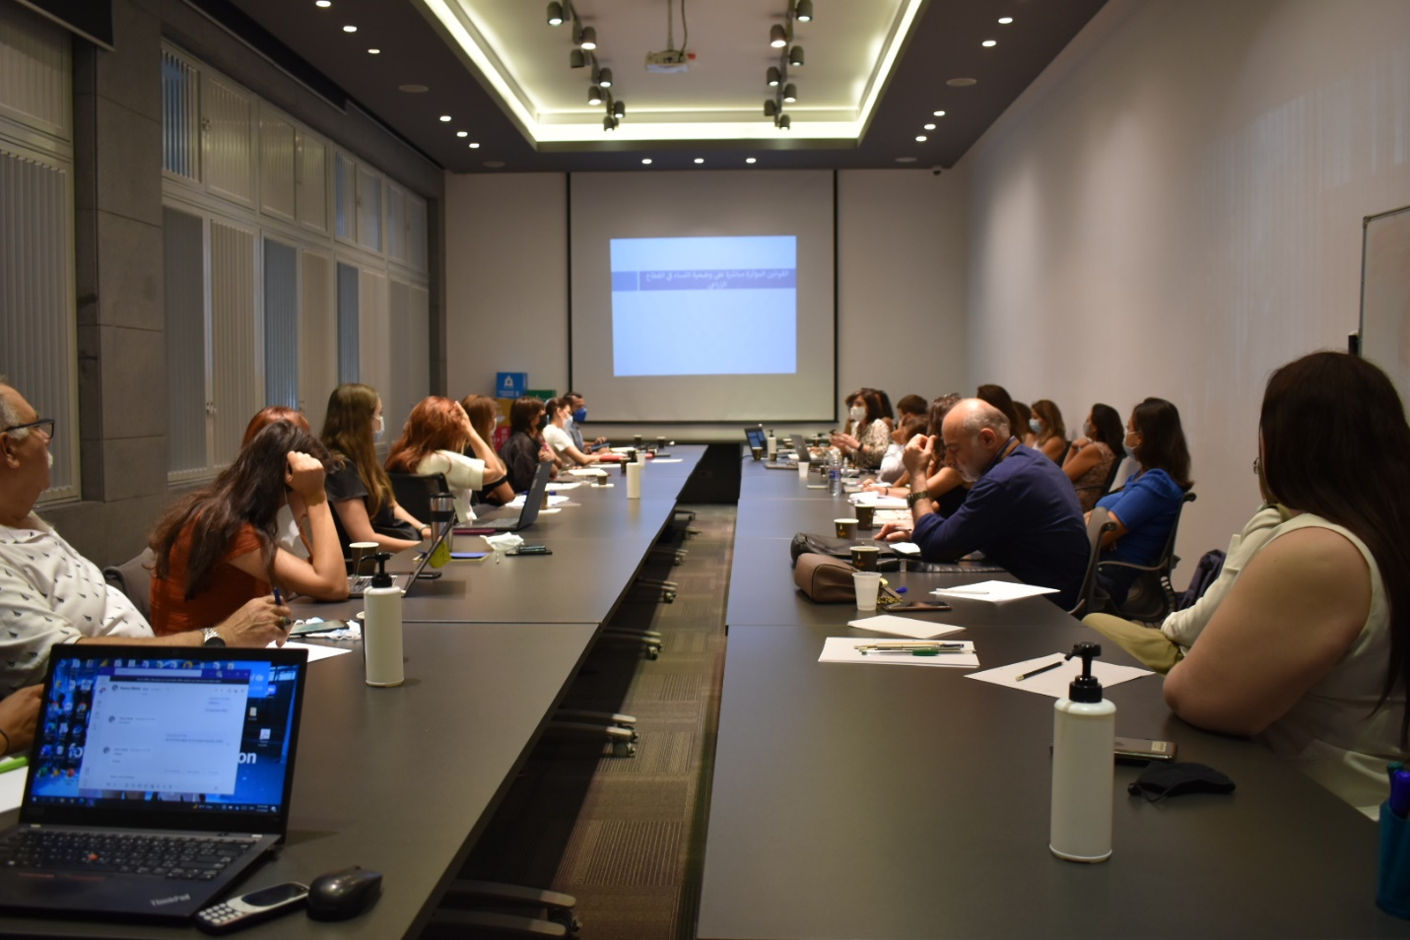
The persisted political deadlock in the country created a barrier to the legislative reforms, nonetheless, the PSDP adapted its approach to work within these constraints, focusing on alternative entry points where PSDP supported the MoL to adopt more gender inclusive language in the submitted draft labour code to ensure a more inclusive and harmonized language and conducted a gender mainstreaming the farmer`s registry and the law of cooperatives by promoting an enhancement in the working environment and safety of women working in the sector.

Picture 1: Legislative review presentation to NGOs, Beirut, Lebanon. Nour Abdul Reda_UN Women, 2022.

iii. The gender audit
The original objective of the gender audit was to conduct it in one of the direct line ministries of the programme: MoA, MoL, or MoI and use the findings of the audit to design a capacity building plan for that ministry on how to efficiently mainstream gender in the various functions and units. However, given the current state of caretaker government and public institutions operating on minimum capacity, it was not possible to conduct the gender audit.
In order to consider the ministries’ vision with regards to gender mainstreaming, the PSDP engaged directly with the gender focal points in each of the MoA, MoI and MoL to discuss:
- How the ministries consider specific gender needs in their functions, for both their staff and their constituency,
- What kind of capacity building initiatives the ministries or international organizations have provided to the ministerial units,
- Whether the ministries have any gender disaggregated data for its services and the public serving, and
- How gender is considered in the ministries` strategies.
These results of the discussions showed that ministries have no specific gender considerations and lack capacity to design, adopt or implement new approaches.

During these discussions, the ministries highlighted the importance of conducting gender audits to help determine how they can be supported in rolling out the priority reforms. Even though the ministries at the time lacked the resources to engage in such an exercise, the focal points learned the importance of participating in a gender audit when the time and resources allow, as they were able to understand how participating in a gender audit would help outline the gender specific capacity building needs of the institution, which would in turn support it in establishing services that are tailored to the needs of the different women constituents.

iv. Gender analyses

The PSDP conducted 2 analyses, “Women’s Voices in the Agriculture and Agri-food sectors in Lebanon” and “Women in Agribusiness: Challenges and Opportunities in Lebanon". The first gender analysis helped portray a clear picture of challenges facing women working in agriculture and agro-food sectors their impact and coping mechanisms. The second one examined the status of agribusinesses and specifically women-led ones in Lebanon by utilizing the Women`s Empowerment Principles as a benchmark.

All the documents produced by the PSDP were disseminated and discussed through various channels: the LCRP livelihoods working group, gender working group, donors, ministries, private sector, CSOs, the national studies repository and UN Women`s global assessment library. These efforts to augment the topic of gender discrimination into public discourse and set the narrative within evidence-based facts and figures, will invariably have a positive impact on future lobbying efforts in support of needed reforms, regardless of the pace in which this is progressing.

Throughout the legislative reform activities, regular coordination took place between PSDP and the Mashreq Gender Facility (MGF), managed by the World Bank, which was implementing related activities to this component. Both PSDP and MGF regularly met, during which PSDP provided updates on initiatives and the progress of the project in the area of legislative reform. This was done to prevent overlap of activities and identify potential synergies. While there was regular engagement and discussions on ways to work together, due to the timing of the projects, there were no specific collaborative outcomes. For example, the MGF was engaged in the development of research on increasing formality amongst agricultural workers and the amendment of the cooperative law, but the development of specific action plans based on findings did not take place during the PSDP project period.

Finally, close coordination between PUNOs was maintained, on various tasks from stakeholder mapping and contacting for the roundtable consultations, to revision and feedback on knowledge products, to support in identifying priority reforms.

v. MACRO Key Results

- 3 key documents published: “Women`s Voices in Agriculture and Agrifood”, Legal and Policy review, and Women in Agribusiness: Challenges and Opportunities in Lebanon". The third? analysis included a baseline and endline analysis for the programme, helped identify the gaps women face under the target sectors, and ensured relevant and gender-responsive planning and implementation during and beyond the PSDP.
- 10 legislative and policies review conducted on women’s right in the workplace.
- Consultations and lobbying efforts conducted with more than 117 stakeholders.
- Ensured ender inclusive language in the submitted draft labour code.
- Gender mainstreaming ensured in the farmer’s registry.
- In one the reform priorities identified, gender mainstreaming was ensured in the law of cooperatives and article 58 of the law (that states that a women can assign a man to vote on her behalf in COOPs election) was revoked.

Outcome 2: The MESO component

The second level of intervention in the programme, referred to as the MESO level, played a vital role in mitigating challenges encountered by women and men-led Micro, Small, and Medium Enterprises (MSMEs) in accessing both local and international markets.

During the inception phase, the PSDP identified 4 key barriers influencing national and international markets access: 1. Access to data and limited market information on trade barriers and external market requirements, 2. Insufficient training and capacity-building programms tailored to prepare businesses for international trade, 3. Limited network opportunities (National and international levels) and 4. Financial barriers to access the needed funding to grow.

In response to these barriers, the PSPD developed an inclusive approach in coordination with the PSDP government counterparts and the private sector and included:

i. Improving government capacities to promote exports

The PSDP developed four interconnected Market intelligence tools with corresponding national trade government counterparts to help farmers and MSMEs understanding external market requirements, acquiring data on the legal and quality requirements for exports and making informal decisions related to market entries:
  - LEBTRADE a national trade platform, in partnership with the Ministry of Economy and Trade,
  - An electronic Platform on Food safety requirements for agricultural products partnership with the Ministry of Agriculture
  - As part of fostering investment opportunities in productive sectors of the economy 6 Pre-feasibility studies were developed in partnership with the Ministry of Industry, and
  - An Export Promotion Platform “Lebanon Exports” in partnership with IDAL to promote Lebanese products.

Developing tailored capacity building programme on export readiness

The PSDP created the “Lebanon Export Academy (LEA)” in partnership with Berytech to improve the export skills of MSME, start-ups and entrepreneurs working in the agro-food value chain. Through the LEA, the PSDP equipped 71 agro-food MSMEs, startups and cooperatives, of which 69% are women-led, with the tools, insights and tips to enable them to export their agro-food products to new regional and international markets. The pilot initiative received a satisfaction rate of 90% from participants. This one-of-a-kind academy shows a successful example of private and public partnership (PPP). A sustainability plan has been developed and 2 Steering Committee (SC) meetings were held in 2023 in order to present the workplan of the academy for 2024 and ensure its sustainability.

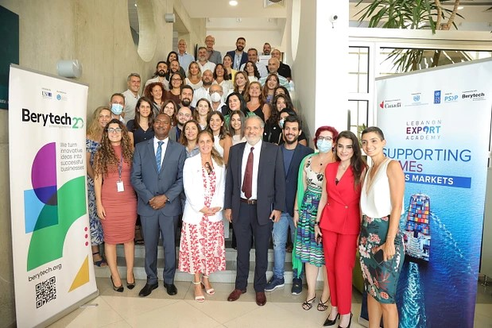
Picture 2: Graduation ceremony of the first Batch of trainers and trainees of the Lebanon Export Academy, 8 August 2022

Providing network opportunities (National and international levels)

The PSDP worked directly with the private sector and facilitated the participation of 160 MSMEs (47% women-led) into 296 B2B meetings through national and international exhibitions to increase their sales and export. These interventions resulted in registering an increase in export, where 13% of supported women-led MSMEs/agricultural cooperatives and 9% of men-led MSMEs/agricultural cooperatives reported increase in their export.

iv. Providing tailored support coupled with financial provision

The PSDP project introduced a novel component aimed at maximizing the impact of support to the private sector, focusing on 50 Micro, Small, and Medium Enterprises (MSMEs) in the agro-food sector who graduated from LEA. This initiative ensured the long-term sustainability of businesses who received various layers of assistance while also securing the livelihoods of individuals across the agro-food sector value chain. The programme leveraged the specific needs and readiness levels of SMEs for accessing local or international markets. PSDP created a seamless and comprehensive pathway for MSMEs to not only produce high-quality goods (MICRO level) but also effectively export them to new markets. Under this level, SMEs were categorized into three categories:

- Category A (18 supported, 50% women-led): Deemed eligible for international market support and received tailored coaching clinics, in-store promotions, participation in international fairs, digital marketing assistance, and trademark registration in key markets. The access-to-market grant was viewed as crucial for companies to solidify and enhance their expansion, with a preliminary survey indicating increased sales and exports for 42% of supported women-led MSMEs/agricultural cooperatives and 50% of men-led MSMEs/agricultural cooperatives.

- Category B (16 Supported, 94% women-led): Assessed as eligible for support to enhance access to national or local markets. Received support for branding, design uplifting, and labeling upgrades and Exhibited at the 2023 Christmas Fair at the Forum de Beirut, generating sales revenues and reporting a 100% increase in sales for both women and men-led MSMEs.

- Category C (16 Supported, 53% women-led): assessed as unready to scale up, receiving coaching support through six one-on-one sessions. Two MSMEs participated in the Arab Summit in Marrakesh, benefiting from networking and fundraising activities. 3 women-led MSMEs participated in the Christmas Market, reporting increased knowledge of quality standards required for exports.

The joint efforts of the PUNOs involved in this component was instrumental in ensuring the success of the programme and was instrumental in ensuring the most optimal selection of the type of access to market support ensuring a full backward and forward integration of the product value chain.
Key Results

- 3 market intelligence tools and 1 export promotion platform developed.
- Successful example of private and public partnership (PPP) created through the establishment of Lebanon Export Academy (LEA)”. 71 MSMEs and start-ups (69% women-led) had their export readiness improved.
- 50 MSMEs (66% women-led) received tailored market access support for reaching new national and international markets.
- 160 MSMEs (47% women-led) conducted 296 B2B meetings through their participation into national and international exhibitions.
- 13% of supported women-led MSMEs/agricultural cooperatives and 9% of men-led MSMEs/agricultural cooperatives reported increase in their export and 100% of supported women and men-led MSMEs registered and increase in their sales.
- The success achieved by the joint efforts delivered by UNDP and UNIDO were key in receiving a new project focused on enhancing access to markets to women-led SMEs.

MESO Key Results

- 3 market intelligence tools and 1 export promotion platform developed.
- The establishment of Lebanon Export Academy (LEA) as a successful example of private and public partnership (PPP). 71 MSMEs and start-ups (69% women-led) had their export readiness improved.
- 50 MSMEs (66% women-led) received tailored market access support for reaching new national and international markets.
- 160 MSMEs (47% women-led) conducted 296 B2B meetings through their participation into national and international exhibitions.
- 13% of supported women-led MSMEs/agricultural cooperatives and 9% of men-led MSMEs/agricultural cooperatives reported increase in their export and 100% of supported women and men-led MSMEs registered and increase in their sales.

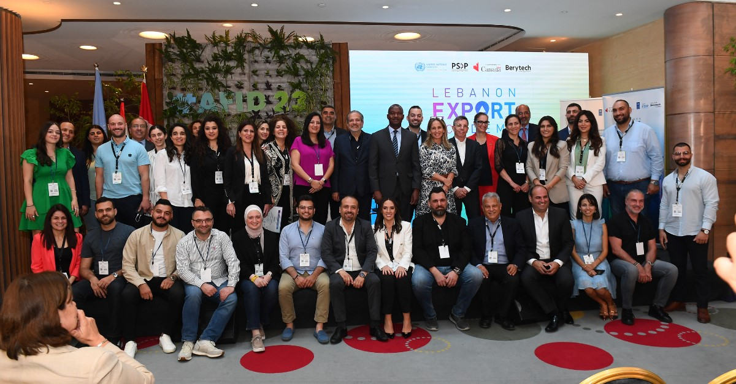
Picture 3: Lebanon Export Academy celebrating the graduation of the second and third batches of SMEs from its programe during the Agri-Food Innovation Days AFID2023
Story 1: Transformational Story provided by Nour Bazaz from Raw Bites

In 2018, Nour Bazzaz and her brothers embarked in one of the most challenging endeavors of an entrepreneur in the Food and Beverage sector: to establish a Lebanese company dedicated to enhance the lifestyle of our new generation with healthy, nutritious and yummy snacks produced from real food only. In other words, their aim is to enlighten people of the greatness and importance of wholefood alternatives to processed “packed” food.
Despite Raw Bites already selling in external markets, Nour wanted to learn and expand more. She enrolled in the Lebanon Export Academy in 2022 and was able to better understand external legal and quality requirements to export her products to different markets and refine her skills on pricing products. This is linked to IO2, which focuses on improving women’s ability to access markets and set pricing strategies through skill development.

Raw Bites didn’t stop there. She applied for the “Access to Market” export grant and sought UNDP’s support to register her trademark in the US, one of the largest and most competitive markets for healthy snacks. The challenge of entering this market didn’t stop her and Nour started the long process of registering her trademark with the help of the UN. This process not only enhanced her business but contributed to the broader PSDP goal of empowering women entrepreneurs to grow their enterprises and increase their exports.

Having her trademark registered will not only provide the brand with legal protection but will also instill confidence in the company’s future American partners and customers.

Outcome 3: The MICRO component

Under this level, the PSDP worked on improving the capacity of MSMEs, agricultural cooperatives, farmers, entrepreneurs, youth and home-based individuals (with specific focus on women) to create and sustain gender equitable job opportunities and adopt environmentally sustainable practices.

This level adopted an area based approach to address key challenges the agriculture and agro-food sectors are facing in Lebanon.

The geographical focus has been centered in Northern Lebanon and Akkar as a result of a participatory technical assessment report conducted in the inception phase, also identifying key partners and determining the value chain. The rationale for selecting Northern Lebanon and Akkar was due to several collective factors based on economic, social, and gender-related considerations in the context of agricultural and agri-food sectors such as ecological diversity, high unemployment rate, linkages opportunities and female engagement.

The report identified the “Fruits, vegetables, nuts and pulses” value chain due to its potential high impact on 4 factors: economic, social/traditional, technological and environmental.

The PSDP identified IDRAC as a key partner in the project to support in providing hands-on training and services to the PSDP beneficiaries. The selection of the center was done following a mapping of existing service centers conducted during the inception phase of the programme and based on agreed selected criteria related to the availability of human resources, infrastructure, the center’s capacity and accessibility and the presence of up-to-date technical equipment related to agro-food processing.

Complementing the technical assessment, the PSDP conducted a technical study for the identification of products to be selected under the value chain and potential interventions as well as a participatory online survey for collecting data on the main actors working in the selected value chain, receiving around 1500 responses. This allowed for easier referrals and compounding effect of multiple packages provided for MSMEs, start-ups, individuals, farmers, youth and women. The survey design was based on a selection criterion identified jointly by the PUNOs, and approved by the Ministry of Agriculture (MoA) for farmers’ criteria & Ministry of Industry (MoI) for the MSME’s and cooperatives criteria. A common PUNOs outreach campaign was conducted along with the online outreach.

The participatory assessments and outreach survey played a crucial role in making data driven decisions on:

- Identifying IDRAC as a key partner in Northern Lebanon to support in providing hands-on training and services to the PSDP beneficiaries.
- Identifying main actors working in the selected VC: MSMEs, agricultural cooperatives, farmers, entrepreneurs, youth and home-based individuals.
- Developing a joint monitoring, evaluation, reporting and learning that assesses benefits achieved, communicates results and identifies areas for improvement. The collaboration and pooling of competencies among the 6 participating UN agencies contributed to a more effective and integrated implementation of the programme objectives.
- Understanding the regions context and designing and planning the 6 integrated packages for providing a diverse range of assistance to selected MSMEs, Agricultural cooperatives, Vulnerable Individuals, Youth and Farmers to ensure a comprehensive coverage of needs and, thus, improve the competitiveness of the selected VC:

The compounding effect of multiple packages provided for MSMEs, start-ups, individuals, farmers, youth and women helped in addressing the needs of these diverse groups by linking beneficiaries and packages of support together. As such, at the MACRO level, consultations and training on PSEA targeted beneficiaries and actors from the MESO and MICRO levels.

On the market access component (MESO level), training on export readiness and national and international market access support included beneficiaries from the MESO and MICRO levels.
At the MICRO level, regular inter-agency meetings were convened to integrate activities and referrals for beneficiaries, including farmers, MSMEs, start-ups and vulnerable women and youth to benefit from the 6 packages.

Package 1: Technological advancement

The PSDP played a significant role in improving productivity, efficiency, and environmental sustainability in the targeted area through technological advancement, particularly in the provision of inputs and manufacturing/environmentally friendly equipment to 406 farmers (248 female and 148 male) and 32 MSMES and entrepreneurs (82% women-led) respectively. Out of the 32 MSMEs, five received both manufacturing and environmentally friendly equipment.

The PSDP used a comprehensive, transparent and participatory method to ensure a holistic evaluation of potential beneficiaries to be supported with technological advancement in Northern Lebanon and Akkar. The selection was done based on an in-depth assessment and field missions using set criteria of selection for the final validation and selection.

A survey of 14 MSMEs receiving manufacturing equipment conducted in November 2023 showed that they have co-invested from their own money 26% of the equipment total value to improve their manufacturing capacity. Additionally, the satisfaction rate for technological advancement shall be measured 6 months following the distribution of equipment.

In addition, the project documents indicated that the intervention aimed to provide training on environmental and energy sustainability, through which beneficiaries received water filtration systems, solar panels, and batteries. According to the evaluation report, the project successfully integrated environmental considerations by focusing on reducing energy costs, diversifying energy sources, and implementing environmental procedures, as reflected in the results. Female-led MSMEs reported greater success in reducing energy costs (3.05 out of 5) compared to their male counterparts (2.92) and were more inclined to diversify energy sources (3.20 for women versus 2.85 for men). Both women and men demonstrated high levels of awareness and adoption of environmental procedures, with scores of 3.06 and 3.00, respectively. Additionally, women showed a slightly higher tendency to implement energy coping mechanisms based on audit findings (3.26 for women versus 3.00 for men). These results underscore the project’s positive environmental impact, particularly for women-led businesses, which achieved better overall outcomes across most areas.

Package 2: Soft skills development

The soft skills trainings and coaching activities addressed various facets of the value chain and were tailored to meet the specific needs of the beneficiaries based on the technical assessment conducted during the inception phase of the PSPD. Well-rounded set of skills contributed to building the capacities of 2,293 vulnerable Lebanese individuals and farmers working under fruits and vegetables, pulses and nuts value chain in Northern Lebanon (74% females, 92% Lebanese and 8% Syrians) and 284 Lebanese MSMEs (76% women-led), more specifically:

- 726 vulnerable women (90% Lebanese) had their knowledge increased on personal leadership and business development and on management and business skills.
- 25 MSMEs (80% women-led) undertook women`s Empowerment Principles (WEPs) training and coaching. As a direct impact, a total of 33 women, 11 of whom are with disabilities, were hired by the 25 MSMEs following the training. The WEP offered practical guidance to businesses on how to empower women in the workplace, marketplace, and community.
- Hands-one training on agro-food processing was provided to 524 vulnerable individuals (87% women-led) and had a direct impact on sales increase of participants (49%) in addition to the adoption of new production techniques (45%).
- 41 MSMEs (54% women-led) were equipped with skills and resources to improve their environmental sustainability with a remarkable 95% satisfaction rate. 60% of women-led and 40% of men-led businesses incorporated environmentally sound practices within their processes following the environmental and energy audits.
- The inclusive and non-stereotyped apprenticeship and workplace-based learning played a crucial role by providing an integrated training package to 517 vulnerable youth (57% female youth), with a strong focus on vocational and life skills relevant to various agricultural and agro-food specializations while addressing social tension through the engagement of both Lebanese and refugee youth in community activities and the development of the social cohesion skills (48% Lebanese/52% Syrians). This package included work-based learning opportunities such as internships and apprenticeships, facilitating the transition of 77 vulnerable youth (49% female) and (56% Lebanese/44 Syrians) from education to employment.
- Lastly, the PSPD included in the soft skills development package to 63 individuals from 7 partners, including Ministry of Agriculture and Industry staff, as well as Berytech, who gained knowledge (70% reported) on sexual harassment. The training ensured that to all their activities are gender sensitive, from design to delivery to monitoring to close-out. Also 23 individuals, including Ministry of Agriculture staff, gained knowledge on basics of gender awareness, PSEA, and protection risks in the agriculture sector.

Package 3: Extension and advisory services to GAP and safer produce

The project introduced an innovative method to enable farmers working under the fruits, vegetables pulses and nuts value chain change their practices and behavior towards applying good agricultural and sustainable practices (GAP) for safer quality produce. The method comprised the establishment of 14 Farmer Field Schools (FFS) and clustering 305 farmers (75%women) by location, gender, and value chain selected. This map shows the distribution of farmers across the FFS.

FFS were used as a platform for farmers to learn through practical, hands-on experiences in the field and emphasized on farmer-to-farmer learning, group dynamics, and a holistic understanding of sustainable agricultural practices. (Click here to learn more about the application of FFS).

The PSPD started with providing a technical training on how to establish and run the 14 FFS for 18 facilitators of IDRAC and MoA. Once they were established and running, the PSDP provided a set of technical trainings on GAP and Occupational Safety and Health (OSH) and digital skills following the full crop cycle in FFS.. As a result, 363 training sessions were held at the FFFS. The FFS group training curricula and modules were complemented with the following:

(i) Individual technical on-farm visits and advice to support farmers, with Specific attention given to women farmers’ needs in applying the phyto-sanitary plan and water schedule and other recommended GAP practices and in moving towards certification. A total of 14 on-farm demonstration plots were conducted.
(ii) Provision of production inputs for both men and women farmers in the FFS groups, supported 406 farmers (248 female farmers and 158 male farmers). The approach was based on farmers’ commitment to trainings and further compliance with certification requirements.
(iii) Agricultural support services to farmers and included water, soil and pesticide residue analysis and production of individual fertilization and water-scheduling programmes. That was coupled with support in submitting applications to ICM and organic farming certifying bodies, along with training and the production of quality ICM manuals for apple produce, which included ICM guidelines and a phytosanitary guide for farmers to help farmers comply with certification requirements and apply IPM.

As a result, 93% of the 284 trained women and men farmers within the Farmer Field Schools (FFSs) reported the adoption of environmentally sustainable agriculture practices (164 female farmers and 120 male farmers). To better evaluate the FFS and PSDP intervention, an endline evaluation of the FFS approach was conducted including focus group discussions (FGDs) in the 14 FFSs.
Story 2: “I want to tell young people my age to follow their dreams”

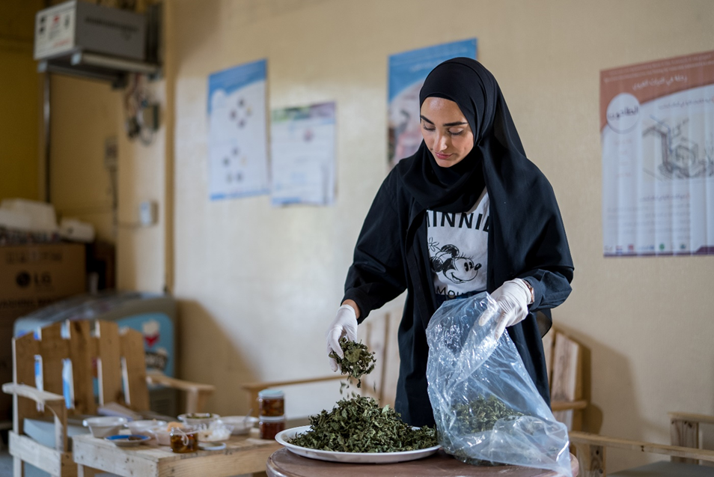

Picture 2: Hayat Hamzeh packing mint, one of her products, in Northern Lebanon. © ILO 2023.

Hayat Hamzeh, 22 years old, comes from Muhammara, a small coastal village in Akkar district. With a big smile, a lot of enthusiasm and a bit of pride, she recounts her journey in which she set up a unique project in her village. “In Muhammara, there are those who prepare and sell pickles, jam, and marmalades. Nobody thought of selling cheese. I now do it in the store that I already had,” says Hayat Hamzeh.

This was possible thanks to the support of PSDP’s training under the Productive Sector Development Programme (PSDP), funded by the Government of Canada. Hayat Hamzeh, a business graduate, followed trainings in cheese production, marketing and life skills. She also took part in several exhibitions around the country.

“I learned how to make cheese. There are a lot of things I didn't know, like pasteurization and cleanliness standards. I also learned to price my products so that I don’t lose money, but I remain competitive on the market,” she says.

Notably, by fostering a more conducive environment for women's participation in productive sectors (IO1), Hayat was empowered to access markets more effectively, set her own pricing strategies and make offers (IO2). Furthermore, the equitable provision of both soft and technical skills enhances the capacity of Hayat, enabling her to grow her businesses using the social media platforms which was seen as an asset for her (IO3).

“I shoot videos and take photos that I share on Facebook and Instagram. I make offers on my products, I also use WhatsApp a lot,” she notes.

Hayat Hamzeh’s story is a clear example of how PSDP’s training directly supports these intermediate outcomes. Through the skills she acquired in cheese production, marketing, and life skills, Hayat not only managed to sustain her business and worked confidently in groups during her trainings, but also leveraged social media and exhibitions to access larger markets outside of her village.

“During life skills trainings, I learned to work in a group to share ideas with others and succeed in putting in place a complete project. I also learned to deal with people, especially those that I don’t know. I realized that there is no difference between human beings, whether they are Lebanese, Syrians or Egyptians, nationals or refugees,” she adds.

Generous and self-confident, she passed on her know-how to all the inhabitants of the village who wanted to learn.

“It’s certainly not easy to start your own business, but you should never give up. Nothing is easy at the beginning, we will face obstacles, but we always end up succeeding, I want to tell young people my age to follow their dreams.”

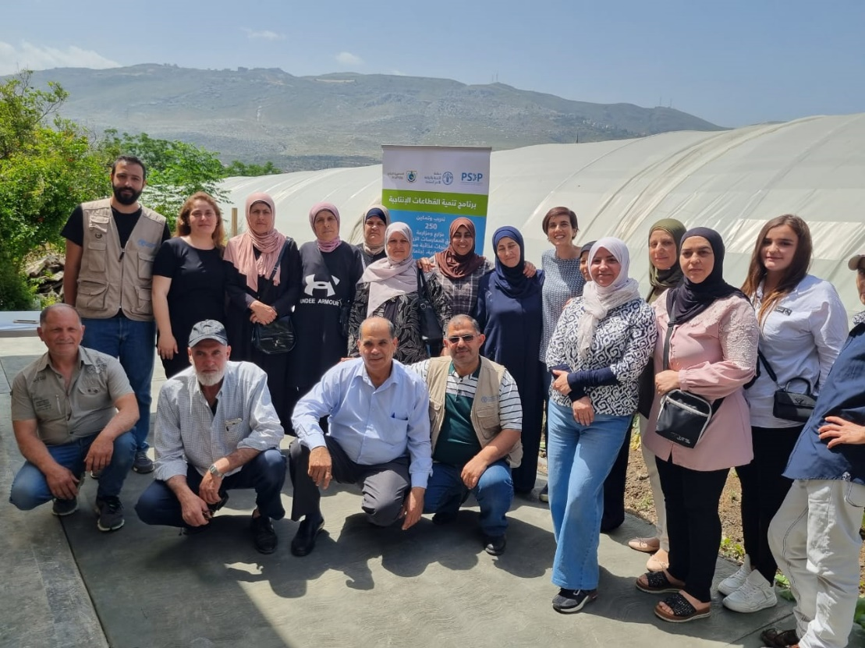

Picture 5: FFS group, North Lebanon. FAO Lebanon, 2023

Story 3: Increased Economic Autonomy and Contribution to Value Chain Productivity: Women Farmers’ Journey
Across multiple value chains, women producers’ potential is restricted by a perceived division of roles and responsibilities between women and men that exclude them from decision-making processes. Women’s participation in value chains is critical, yet they still face gender-specific constraints and challenges in owning, assessing, and controlling resources that affect their productivity, livelihood, and income.

PSDP adopted the Farmer Field School (FFS) as an entry point for promoting women’s participation in the fruit and vegetable value chain and addressing gender inequalities. FFS strengthens farmer’s know-how through experiential learning and regular meetings throughout the crop cycle. This has led to significant improvements and benefits for women farmers involved in the PSDP and FFS programmes, notably by paving the way for a more enabling environment for women to participate in productive sectors (IO1) and allowing them to better access markets and set their own pricing strategies and negotiating with different market actors (IO2). Additionally, through the equitable delivery of soft and technical skills, the capacity of farmers and COOPs is maximized, allowing them to expand their businesses and thereby creating additional job opportunities (IO3).

Men and women farmers were able to interact on an equal basis at the individual, farm, household and village levels. “Mixing and applying pesticides used to be my husband's work,” said Dalal, a farmer.

In North Lebanon, a female farmer named Darine noted improvements on multiple fronts. “Thanks to the trainings and inputs I received, I am applying integrated pest management and keeping records. I have safer, better-quality produce, and I am now deciding on everything along with my brother,” said Darine.

Another female farmer, Amira, is now confident of her technical and negotiation skills. “I can be in the wholesale market, bargaining and selling my products,” said Amira proudly.

Dalal, Darine, and Amira are now seeking to further improve their farming businesses and increase the value addition of their produce by producing high quality cops free of pesticides through the application of the integrated pest management system.

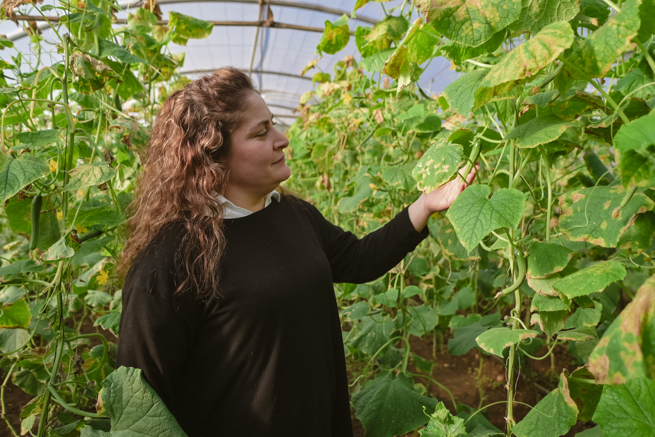

Picture 6: Darine, female farmer from Akkar standing next to her safe produce. FAO Lebanon, 2024.

In North Lebanon, a female farmer named Darine noted improvements on multiple fronts. “Thanks to the trainings and inputs I received, I am applying integrated pest management and keeping records. I have safer, better-quality produce, and I am now deciding on everything along with my brother,” said Darine.

Another female farmer, Amira, is now confident of her technical and negotiation skills. “I can be in the wholesale market, bargaining and selling my products,” said Amira proudly.

Dalal, Darine, and Amira are now seeking to further improve their farming businesses and increase the value addition of their produce by producing high quality cops free of pesticides through the application of the integrated pest management system.

Package 4: Gender Sensitivity business development support and entrepreneurship training

The needs assessment on “Key challenges and opportunities facing entrepreneurs in the agriculture and agro-food sectors in North-Lebanon and Akkar” conducted during the inception phase of the project highlighted on the importance to target early-stage start-ups, home-based enterprises and young entrepreneurs seeking strategic support for idea expansion. The prioritization of financial assistance was also another main recommendation based on interviews conducted with different counterparts; subsequently a grant-scheme was integrated in the implementation design in order to provide beneficiaries with learning incentives.

The PSDP used the “Women Do Business” (WDB) training package for adaptation and as a basis for “knowledge-transfer” through training and coaching, reaching 218 MSMEs (95% women-led) This programme targeted women entrepreneurs/ owners of existing micro-enterprises, or women working in income generating activities for more than a year who wish to develop and grow their activities into micro-enterprises.

The roll-out of the WDB training consisted of two main activities:

- Training of trainers (ToT) to 18 candidate profiles and business coaching practitioners including profiles from IDRAC and UNWOMEN implementing partner the Lebanese League of Women in Business (LLWB). Based on the evaluation, 15 candidates became certified to become business development and entrepreneurship coaching practitioners in the Agro-food and Agricultural sectors using WDB material.

- Implementation of the knowledge-transfer activity through WDB and advanced business resilience curriculum in 4 main progressive cycles which allowed prominent 218 MSMEs (95% women-led) successfully to advance gradually:

Cycle 1: Women do business training: 218 MSMEs (95% women-led) successfully demonstrated committed participation and exceeding 9% of the planned target (200) on various entrepreneurial aspects, from ideation to market analysis and financial planning, fostering a holistic understanding and practical application of business principles
Cycle 2: Advance business resilience: This training cycle engaged 108 committed MSME owners (102 women-led) and resulted in the submission of 102 feasibility studies.
Cycle 3: Business Plan competition: A jury composed of 8 members from different PSDP participating agencies and developmental partners evaluated and selected 20 MSMEs to receive a grant- scheme and a 1 on 1 extended coaching.
Cycle 4: Grant- scheme and coaching were designed to 20 selected MSMEs (95% women-led)

Finally, in efforts to provide selected PSDP participants with knowledge on formalization, a common activity with EU-funded project, SOLIFEM, implemented by the ILO, was created. The activity aimed to increase the awareness on business formalization, improve the know-how, and to guide the implementation of SOLIFEM through the formalization help-desk in collaboration with the Association of Lebanese Industrialists (ALI), expected in 2024. The formalization sessions reached 34 participants in Akkar and Tripoli. The effectiveness of the training was assessed through pre and post-tests, showing an average improvement of 19.69% in Mhamra and 25.9% in Tripoli. Notably, women demonstrated a higher average improvement (23%) compared to men (17.5%), with the youth segment (18-24 years) exhibiting the most significant progress at 27.5%. Feedback highlighted a satisfaction, with 64.5% strongly agreeing that the content was beneficial.

Through a data collection exercise to assess the impact of the knowledge transfer targeting 218 MSMEs (95% women-led), conducted with 176 responses and interviewees, the below section summarizes the impact on supported participants, 15 months after the implementation of the activity (WDB and advanced business resilience workshop):

- 73% of MSMEs received assistance are operational, with 27% temporarily closed; however, 77% of these closed businesses are planning to reopen, while 23% opted for permanent closure due to insufficient financial backing.
- 69% of MSMEs reported increased production, with a substantial 32% experiencing over a 200% surge.
- Marketing strategies were revamped by 76% of businesses, yielding positive impacts.
- 78.1% MSMEs observed a monthly profit increase below $500
- 17.1% MSMEs saw profits ranging between $500 and $700 and a noteworthy 4.8% surpassed $700.
- Additionally, 44% successfully initiated the formalization process.
- Regarding product development, 52% of business owners heightened their engagement with quality control services, resulting in 71% confirming improvements in product quality.
- Entrepreneurial skills flourished among 98% of business owners, showcasing adeptness in managing challenges, bolstering confidence, and disseminating knowledge within their communities.
- 88% expanded into new markets and forged connections with diverse stakeholders, while 86% began procuring raw materials directly from farmers, signaling increased self-reliance and local engagement in the supply chain.

The following analysis focuses more in depth on the pool of beneficiaries who were supported with the grant-scheme:

- A large majority (80%) managed to augment their sales profits and production, indicating a healthy growth trajectory.
- 60% of these businesses moved to specialized workspaces, while a smaller percentage 20% enhanced their existing work environment.
- Additionally, a noteworthy 20% continued operations from home, maintaining flexibility in their setup.
- Accessing IDRAC services seems to have been highly beneficial, with 90% reporting improved product quality.
- Moreover, an overwhelming 90% successfully tapped into new markets and business opportunities, demonstrating an impressive expansion, while a smaller fraction (10%) maintained their existing networks, suggesting a balanced approach between forging new connections and sustaining current relationships. Overall, these figures illustrate a broad positive trend in business development and adaptability among the surveyed enterprises.

Package 5: Institutional support

The institutional support provided to the Ministry of Agriculture and to the Industrial Development and Research Agro-Agri Center (IDRAC) hosted by the Chamber of Commerce, Industry and Agriculture in Tripoli intersects with the 4 other packages provided by the programme.

As such, IDRAC was provided with different tools and services to facilitate its ability to deliver the necessary support to the PSDP beneficiaries and the MoA role was more related to the FFS. IDRAC was supported with the following

- Manufacturing equipment: from laboratory tools, machineries for cooking, destoning, squeezing and juicing and a line for potatoes frying and cooling. The machineries received helped in (i) introducing two new techniques related to frozen potatoes and juices, (ii) supporting start-ups not being to operate their full production at their facilities due to their limited capacity will use IDRAC facility (iii) attracting more than 20 new start-ups and entrepreneurs in Northern Lebanon, (iv) incubating 7 new business and (v) improving 5 new products in the fruits, vegetables, pulses and nuts value chain.
IDRAC center has already an industrial permit from the MoI, which make the center sustainable and able to maintain and use the machineries in an efficient way.
- Training and coaching on how to establish and run 14 FFS.
- Certification Integration (ICM): IDRAC hosted the Integrated Crop Management (ICM) guidelines for certifications for Apple producers on ICM.
- Financial support to conduct laboratory tests for farmers and MSMEs.
- PSDP provided knowledge transfer to 4 selected trainers from IDRAC on the" Women Do Business" training curriculum. Through the Training of Trainers (ToT) activity and the monitoring of the field implementation to end-line beneficiaries, 4 representatives from IDRAC became certified by the ILO to practice business development coaching for start-ups and MSMEs working in the agro-food sector.
- To encourage PSDP participants and MSMEs to access business development services available at IDRAC and to encourage the integration of quality control and testing practices in the business operations of rural MSMEs, a seed-fund was integrated for 20 MSMEs to test their products and receive technical feedback from IDRAC experts on how to improve the product. The total value of the seed fund is 5,130.00 USD.
As for the Ministry of Agriculture, its role was directly related to the FFS through:

- Establishing and implementing the FFS using the full crop cycle approach in Northern Lebanon and Akkar to carry out the trainings for the farmers.
- Training and coaching on how to establish and run 14 FFS was conducted to the MoA facilitators. Coaching tools, typically included curricula for practical, hands-on learning in sustainable agricultural practices.

This assisted in capacity building for trainers and facilitators involved in farmers' field schools, ensuring that educational programms are of high quality and have a meaningful impact on participating farmers.

Story 4: Andkit cooperative stands as a testament to local entrepreneurship

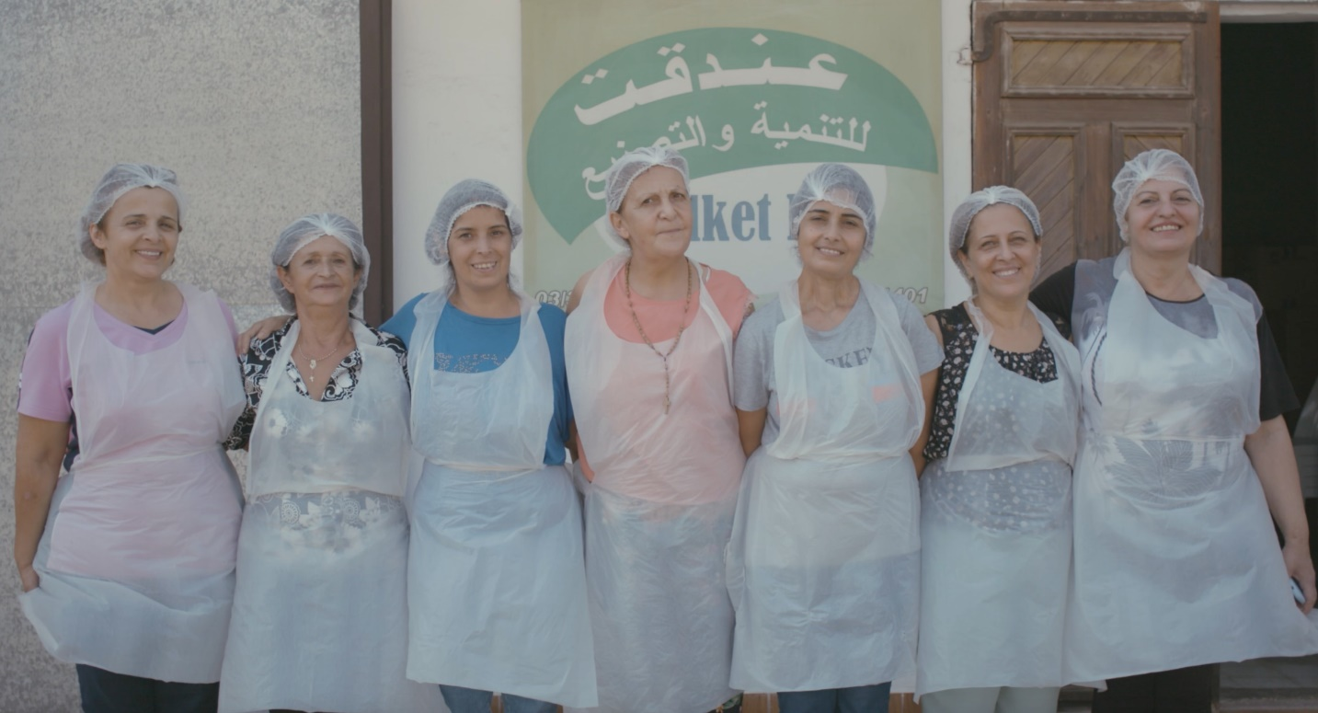

Picture 4: Andakit Pro Cooperative Members, Andakit, Northern Lebanon, Photo by Chloe El Khoury. UNIDO 2023
Established in 2006, the cooperative was born to ignite an economic flame for the women of the village. Named "Jana al Dayaa" (the village's harvest), their brand symbolizes their commitment to reaping and crafting the essence of their land within the cooperative's walls. This cooperative of 18 women members spanning ages from 20 to 83 recently welcomed three new young members who sparked the idea for a new product—peanut butter.

Their breakthrough came as a result of PSDP's capacity-building programme under intermediate outcome 3 (Micro): “Improved capacity of women farmers, women-led cooperatives and women-led micro, small and medium enterprises (MSME), as well as men-led entities in productive sectors to create and sustain gender equitable job opportunities and adopt environmentally sustainable practices”.

Under this outcome, the programme organized technical skills training in the target value chain and targeted 524 vulnerable individuals from Northern Lebanon (75% women). The training offered both theoretical and practical segments and included a comprehensive peanut butter production course amongst others at (IDRAC) in Tripoli.

In the theoretical part, the cooperative learned the nuances of sourcing quality peanuts, emphasizing the importance of selecting sources and ensuring quality. They were introduced to flavor infusion techniques, adding elements like honey and sometimes strawberry jam. This theoretical foundation laid the groundwork for their practical training.

“We are proud of ourselves, proud to have reached such a production level and proud to be part of a cooperative of women supporting each other,” expressed Marleine, the president of Andakit Pro Cooperative.

The practical sessions were hands-on, involving peanut roasting, timing considerations, mastering the process of mashing peanuts, and determining optimal moments for honey infusion and jar filling.

With PSDP’s assistance in developing personalized labeling for their new peanut butter and jams lines, Andakit Pro Cooperative reported that the quantity of production increases up to 10kg and the cooperative registered 75% increase in sales.

In addition, the cooperative presented its products, notably the peanut butter, at a bustling Christmas market in Beirut, Lebanon from 15 till 23 of December 2023. This marketing activity was also organized by the PSDP as part of the intermediate outcome 2 (Meso) of the programme “Improved access to markets for women and men-led Micro, Small and Medium Enterprises in productive sectors” In addition to promoting the cooperative and learning important lessons on how to present themselves, the Andakit Pro Cooperative was also able to register an increase in sales and sell products during the 10 days of exhibition.

Finally, in terms of employment, the programme contributed to supporting jobs both directly and indirectly and thanks to PSPD, Andakit Pro Cooperative was able to maintain the jobs of 30 employees of the cooperative (out of which 18 are women members).

Package 6: Direct market access activities (National & International levels)

Market access activities at the micro level started at the grassroot level with micro and small industries, entrepreneurs and farmers who already received technical support from the PSDP. It focused on four elements: re-branding, certification, formalization, and direct access to national and international markets.

Rebranding was instrumental to facilitate market access of MSMEs who received manufacturing equipment or developed new products. The PSDP worked on refreshing and redesigning the brand's logo and visual elements of 17 products related to baby food based on fruits and vegetables, Mouneh products and others. The PSDP ensured that the visual identities created are modern, relevant, and aligned with the original brand's values. Also, the PSDP supported 15 MSMEs in testing their products at IDRAC in order to ensure the safety and quality compliance before reaching the market.

Formalization: The formalization of MSMEs is essential for ensuring the long-term success of the support provided. Yet, the informality of MSMEs in Northern Lebanon is relatively high, and it was one of the challenges the PSDP faced when selecting the MSMEs (Total: 15) to be supported with manufacturing equipment. The PSDP played a crucial role in guiding 5 MSMEs on the proper documentation needed for obtaining necessary permits from the Ministry of Industry. Until present 3 out of 5 were able to get their permits, the strikes of the government departments in Northern Lebanon have hindered the process. This bureaucratic challenge was beyond the control of the programme.

In addition, the formal organization of Farmer Field Schools (FFS) groups was crucial for the long-term sustainability of the programme. While the FFS provided a platform for clustering farmers and enhancing their skills, it did not constitute formal entities. To ensure legal recognition and sustainability, 3 of the FFS groups were encouraged and supported to establish cooperatives. This support included training on cooperative establishment, developing feasibility plans, and preparing official documents for formalization. This component was implemented in close coordination with the Directorate of Cooperatives. As a result, 2 out of 3 groups are now in the process of finalizing their registration as cooperatives.

Certification: Following the support provided by the PSDP, 69 apple producers (49 women-led), were awarded integrated crop management (ICM) group certification, including 4 of which received the organic certification . The certification received provided a testament that the quality and safety of produces is high and assured consumers that the produce meet specific standards and have undergone rigorous testing and evaluation.

Direct market access: access to markets was a critical factor for the sustainability and growth of micro and small enterprises and farmers who already received technical assistance from the PSDP. The approach adopted under this level was inspired by and aligned with the categorization of beneficiaries conducted under the MESO level for national and international market access support.

National market access support:

- The PSDP partnered with Le Marché Bio to provide sustainable backing to 8 MSMEs (87% women-led). They were selected after ensuring their compliance with the local regulations, obtaining the relevant certifications and ensuring their understanding of the market requirements in their commercial endeavors. The selection of Le Marché Bio stemmed from its demonstrated interest and capacity in encouraging locally crafted products by rural Lebanese women supported through PSDP.
- Four apple producers’ groups who acquired ICM certification were linked to traders and other local actors along the apple value chain. According to the Endline evaluation of the FSS approach, several groups reported that the project enabled them to engage in group marketing or to provide market linkages for their produce.
- 30 different beneficiaries from MSMEs, farmers and start-ups participated in HORECA 2024 as part of the closing ceremony of the programme. Beneficiaries had the chance to promote their products and conduct B2B meetings with national and international buyers.

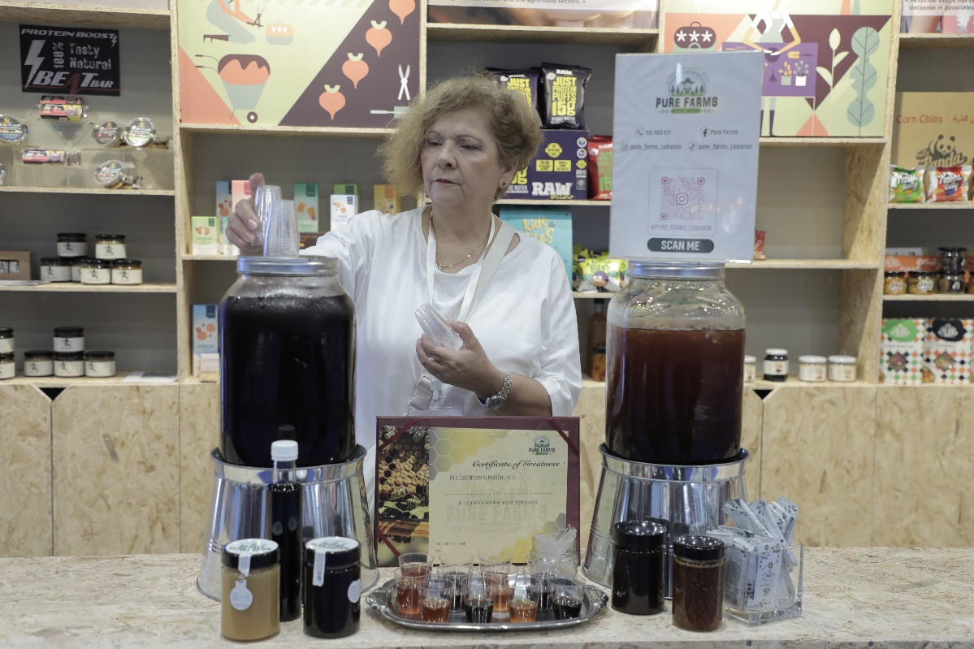

Picture 5: Pure Farms, a PSDP beneficiary, displaying products at the PSDP Booth at Horeca Expo on April 17, 2024. The booth featured products from over 30 businesses, including Mouneh, fruits, and vegetables. (Photo credit: UNDP)
International Market access support:
- 15 MSMEs and farmers (80% women) participated in the Arab SME Summit that took place in Marrakesh from 12 to 14 December 2023. SMEs had the ability to sell their products directly in a bazar forum organized by ESCWA. Moreover, the PSDP secured a booth for the PSDP itself to promote the programme.
- The summit provided a large business exposure especially for women producers where they had the chance to interact with their peers on equal basis with men by which this greatly empowered all female participants to engage with their counterparts from the Arab region sharing experiences, challenges faced, and committing towards woman empowerment. Overall, 80% of participants provided feedback of a very successful participation in the summit that will help them advance their businesses on many levels (Summit report).

MICRO Key Results

- 14 Farmer Field Schools (FFS) established.
- 406 Farmers (61% female) were directly supported with inputs/agriculture tools and tests.
- 32 MSMES and entrepreneurs (82% women-led) received both manufacturing and environmentally friendly equipment.
- 14 MSMEs (100% women-led) co-invested 26% in cost of the machine or for rehabilitation work.
- 2293 (74% females, 92% Lebanese and 8% Syrians) individuals received technical trainings on agri-food processing, business leadership, environmentally sustainable agriculture, formalization, Gender awareness, protection and PSEA, sexual harrasement and apprenticeship and workplace-based learning.
- 284 Lebanese MSMEs (76% women-led) received training and coaching on women's Empowerment Principles (WEB), environmental sustainability training and auditing and women do business coaching.
- 7 partners gained knowledge on sexual harassment, with 70% increase in knowledge reported among the participants.
- 4 representatives from IDRAC became certified on "Women Do Business".

Indicator based performance assessment

Using the Programme Results Framework from the Project Document / AWPs - provide details of the achievement of indicators at both the output and outcome level in the table below. Where it has not been possible to collect data on indicators, clear explanation should be given explaining why (more details can be found in the evaluation report).

 | Indicator | Baseline | Planned Target | Achieved Indicator Targets | Reasons for Variance with Planned Target (if any) | Source of Verification
MACRO
Intermediate Outcome 1 (Macro): Improved enabling environment for women`s economic empowerment and participation in productive sectors | Indicator 1.a: # of laws/regulations that address women’s participation in informal sector and promote women economic empowerment, specifically agriculture and food/home-based businesses revised and submitted for adoption to parliament | 0 | 3 | 1 | Target was not achieved due to the parliamentary deadlock over electing a President, which has made it almost impossible to introduce new or amended laws or regulations for adoption by Parliament. However, one legislative framework was submitted, referencing Article 58 of Executive Decree No. 2989 of 17/4/1974, which states that a woman was given the right to delegate a man to vote on her behalf in cooperative elections. | # of laws/regulations submitted to the MPs.
Immediate Outcome 1.1: Improved understanding of the reforms needed to address key barriers for women economic participation in productive sectors. | Indicator 1.1.a: # of key government/parliament members who have increased awareness of the needed reforms and have participated in key dialogue initiatives. | 0 | 15 | 8 | Following the above variance explanation, UN Women was unable to approach more MPs to discuss the needed reforms due to political consideration. Also, the consecutive crises in the country, with the most recent being the uncertainty about Lebanon being dragged into a regional war did not help to achieve this target. | # of key government /parliament members attending dialogue/meeting
Output 1.1.1: Conduct gender analysis (using feminist and participatory approaches) and generate gender analysis reports on intervention areas. | Indicator 1.1.1.a: # of Gender Analysis reports developed. | 0 | 2 | 2 | No variation reported | # of reports published
 | Indicator 1.1.1.b: # of NGOs and feminist associations engaged in the gender analysis. | 0 | 10 | 10 | No variation reported | Association listed in the consultation of the published gender report
 | Indicator 1.1.1.c: # Gender Sensitive Legislations examined related to selected sectors. | 0 | 2 | 10 | No vacation reported. In total, 10 legislations were examined to determine the gender gaps that exist in the texts. Out of these 10, 4 legislations were studied in detail, from a causation angle, affecting women`s work in the sectors: labour code, National Social Security Fund (NSSF) Code, Land Ownership, and Law of Cooperatives. The 6 remaining were examined correlatively, looking at indirect linkages between the legislations and the situation of women in the sectors: credit and financing code, code of land commerce, code of taxation, public procurement code, code of investments. | # Legislation in published recommendation
Output 1.1.2: Develop gender responsive policy and legislative reforms related to agriculture/food/home-based business sectors which address key barriers for women’s economic participation in order to facilitate policy dialogue and reform amongst national stakeholders, government bodies, and the private sector | Indicator 1.1.2.a: # of comprehensive gender audits developed | 0 | 1 | 0 | During the legislative prioritization consultations with the relevant ministries (MoI, MoL, and MoA), the focal points stressed on the complete institutional collapse in all their ministries, with barely any staff attending work due to fuel shortages and unpaid salaries, in addition to lack of ministerial budgets to carry out any programmatic activity. As such, and as mentioned above, engaging with ministerial staff to conduct a gender audit would be challenging and futile at this point of time when the crises in country are still further escalating
 | Indicator 1.1.2.b: # of public officials and lawmakers supporting new policies for gender mainstreaming | 0 | 10 | 8 | While the 8 consulted MPs have expressed their support of the prioritized reforms, they have not officially signed any new and/or amended policy or regulation. | # signatories on new policies
 | Indicator 1.1.2.c: # of political parties/ movements supporting of new policies for gender mainstreaming | 0 | 7 | 8 | No variation reported. The 8 MPs consulted and confirmed represent 4 political parties, with one being an independent. | # signatories on new policies
 | Indicator 1.1.2.d: # employers and businesses engaged in lobbying efforts to initiate internal reforms for a more inclusive business environment | 0 | 15 | 74 | No variation reported. This total is comprised of 74 institutions that have participated in policy dialogue with UN Women during consultations and participation in common workshops. | # signatories on new policies
 | Indicator 1.1.2.e: # of employers have increased awareness of the needed policy reforms | 0 | 70 | 80 | No variation reported. | # of attendees in attendance list
 | Indicator 1.1.2.f: # of syndicates who have increased awareness of the needed policy reforms | 0 | 2 | 2 | No variation reported. | # of attendees in attendance list
 | Indicator 1.1.2.g: # of local actors partnered with for lobbying efforts | 0 | 10 | 27 | While the advocacy and lobbying activities have been stalled due to the current country context during this reporting period, 27 actors (humanitarian organizations, CSO, academia, and private sector) had committed to join the advocacy group with UN Women. This commitment was made during the roundtable consultations that took place between June and September 2022. | # signatories for partnership
MESO
Intermediate Outcome 2 (Meso): Improved access to markets for women and men-led Micro, Small and Medium Enterprises in productive sectors | Indicator 2.a: % of supported women led MSMEs/agricultural cooperatives that register an increase in their exports. | 0% | 30% | 13%  10 out of 75 women led MSMEs increased their exports | This indicator has a long-term impact and its results cannot be measured directly after the completion of the B2B meetings and matching activities. | Post-evaluation survey
 | Indicator 2.b: % of supported men led MSMEs/agricultural cooperatives that register an increase in their exports. | 0% | 30% | 9%  8 out of 85 men led MSMEs increased their exports | This indicator has a long-term impact and its results cannot be measured directly after the completion of the B2B meetings and matching activities. | Post-evaluation survey
 | Indicator 2.c: % of women led MSMEs registering an increase in sales (% from the total supported) | 0% | 50% | 100%  17 out of 17 supported women-led MSMES registered an increase in sales | No variation reported. | Post-evaluation survey
 | Indicator 2.c: % of men led MSMEs registering an increase in sales (% from the total supported) | 0 | 50% | 100%  2 out of 2 supported men-led MSMEs registered an increase in sales | No variation reported. | Post-evaluation survey
Immediate Outcome 2.1: Enhanced capacity of national institutions to support exports in productive sectors and promote women. | Indicator 2.1.a: # of institutions strengthened or established. | 0 | 5 | 5 | No variation reported | Institution’s portals (Berytech, MoI, MoA, MoET and IDAL)
Output 2.1.1: Export Promotion platform at IDAL | Indicator 2.1.1.a: # Export Platform Development | 0 | 1 | 1 | No variation reported | IDAL website portal: https://lebanonexports.gov.lb/
Output 2.1.1: Export Promotion platform at IDAL | Indicator 2.1.1.b: # of women and men led MSMEs registered on the IDAL Exporter Directory | 0 | 200 | 232 | No variation reported | Number of profiles listed on IDAL Exporter Directory to be shared by IDAL
Output 2.1.1: Export Promotion platform at IDAL | Indicator 2.1.1.c: # Market reports produced for countries with high export potential. | 0 | 10 | 9 | The only variation is the # Market reports produced for countries with high export potential. 9 were developed instead of 10 because 2 countries were merged in 1 report. | Publications uploaded on website
Output 2.1.1: Export Promotion platform at IDAL | Indicator 2.1.1.d: # of international visitors accessing the Export Platform | 0 | 500 | 124,108 Local and international | No variation reported | The # of visitors include both local and international as differentiation if not possible and number of clicks on this section through Google analytics
Output 2.1.1: Export Promotion platform at IDAL | Indicator 2.1.1.e: # of international visitors accessing the Market Reports | 0 | 40 | 497 | No variation reported | Number of clicks on the section using google analytics
Output 2.1.1: Export Promotion platform at IDAL | Indicator 2.1.1.f: # of women and men-led MSMEs attending fairs | 0 | 30 | 160 | No variation reported | List of women and men-led SMEs attending fairs
Output 2.1.1: Export Promotion platform at IDAL | Indicator 2.1.1.g: # of international B2B meetings conducted by supported MSMEs. | 0 | 25 | 296 | No variation reported | Post evaluation sheets
Output 2.1.1: Export Promotion platform at IDAL | Indicator 2.1.1.h: # IDAL employee trained on updating Portal Information | 0 | 3 | 3 | No variation reported | List of Employees trained
Output 2.1.1: Export Promotion platform at IDAL | Indicator 2.1.2.a: Development of Agro Food Section of LEBTRADE portal | 0 | 1 | 1 | No variation reported | LEBTRADE website portal: https://lebtrade.gov.lb/
Output 2.1.1: Export Promotion platform at IDAL | Indicator 2.1.2.b: # of women and men-led MSMEs accessing LEBTRADE portal agro food services information | 0 | 50 | NA | It was not possible to retrieve the # of women and men-led MSMEs accessing LEBTRADE portal agro food services information.
Output 2.1.1: Export Promotion platform at IDAL | Indicator 2.1.2.c: # Market reports produced for products with high export potential. | 0 | 8 | 7 | The # of Market reports produced for products with high export potential was not achieved (7 instead of 8, because 2 sectors were merged in 1 report). | Reports uploaded on the website
Output 2.1.1: Export Promotion platform at IDAL | Indicator 2.1.2.d: # of public sector employee trained on developing market intelligence report studies and on identifying promising markets for agro food products. | 0 | 3 | 2 | The # of employees trained was 2 and not 3 as planned since 2 employees from the MoEt were assigned to work on the portal. | The list of employees trained
Output 2.1.3: Export Training center and online Academy | Indicator 2.1.3.a: # of online portal developed. | 0 | 1 | 1 | No variation reported | LEA portal: https://lebanonexportacademy.com/
Output 2.1.3: Export Training center and online Academy | Indicator 2.1.3.b: # of technical training programmes developed by the center. | 0 | 10 | 9 | The number of modules developed for the in-person training is 11. However, when the LMS (online version) was developed, modules were customized and some were merged. That is why the number achieved is 9 and not 10. | Training courses developed and are present on the website
Output 2.1.3: Export Training center and online Academy | Indicator 2.1.3.c: % of women and men trained that report a high level of satisfaction with the training. | 0 | 70% | 90% Average satisfaction level of the 71 trained MSMEs | No variation reported | Post-training Evaluation and Berytech Final Report
Output 2.1.3: Export Training center and online Academy | Indicator 2.1.3.d: # of beneficiaries that benefited from the training center and the online academy. | 0 | 70 | 71 (69% women-led MSMEs) | No variation reported | Final list of attendees and Berytech Final Report
Output 2.1.4: Pre-feasibility studies for MoI | Indicator 2.1.4.a: # of pre-feasibility studies | 0 | 6 | 6 | No variation reported | Number of studies published on MoI website: http://www.industry.gov.lb/PublicationsAndStudies/Feasibility-Studies-2022
Output 2.1.4: Pre-feasibility studies for MoI | Indicator 2.1.4.b: # of public employees trained on pre-feasibility studies. | 0 | 5 | 8 (87.5% female) | No variation reported | List of public employee names trained.
Output 2.1.4: Pre-feasibility studies for MoI | Indicator 2.1.4.c: # of women and men led MSMEs accessing pre-feasibility studies. | 0 | 10 per report | 1313 | No variation reported | Number of clicks on the section using google analytics
Output 2.1.5: Food safety standards at MoA | Indicator 2.1.5.a: Web page on Food Safety standards published. | 0 | 1 | 1 | No variation reported | Portal developed: https://regulations.agriculture.gov.lb/
Output 2.1.5: Food safety standards at MoA | Indicator 2.1.5.b: # of food safety regulation reports published. | 0 | 10 | 123 | No variation reported | Reports published on the website
Output 2.1.5: Food safety standards at MoA | Indicator 2.2.5.c: # of public employees trained on streamlining and simplifying access to food safety regulations. | 0 | 3 | 13 (77% female) | No variation reported | Attendance sheet of trained staff at the ministry
Output 2.1.5: Food safety standards at MoA | Indicator 2.1.5.d: # of women and men led MSMEs accessing food safety standards. | 0 | 25 | 10,309 | No variation reported | Number of clicks on the section using google analytics
MICRO
Intermediate Outcome 3 (Micro): Improved capacity of women farmers, women-led cooperatives and women-led micro, small and medium enterprises (MSME), as well as men-led entities in productive sectors to create and sustain gender equitable job opportunities and adopt environmentally sustainable practices. | Indicator 3.a: % of MSMEs participating in the WEPs training who have signed and implemented the Women Economic Empowerment Principles within 6 months of having finished the training. (UNWOMEN) | 0 | 50% | 100% | No variation reported | List of MSMEs
 | Indicator 3.b: # of permanent jobs created for women. (FAO) | 372 | 5 | 23 | No variation reported | Employment data collection sheet
 | Indicator 3.c: # of permanent jobs created for men. (FAO) | 535 | 5 | 12 | No variation reported | Employment data collection sheet
 | Indicator 3.d: # of jobs maintained for women. (FAO) | 372 | 50 | 177 | No variation reported | Employment data collection sheet
 | Indicator 3.e: # of jobs maintained for men. (FAO) | 535 | 50 | 129 | No variation reported | Employment data collection sheet
 | Indicator 3.f: # of daily jobs (seasonal labourers) created for women. (FAO) | 598 | 5 | 84 | The job creation element was due to an increase in yield, and therefore more seasonal labourers were hired for harvesting and pruning. This also resulted from the ability of farmers now to hire more seasonal labourers, as they have more motivation to sustain their farming business as a result of in-kind support (input distribution).  Farmers did not note an increase in job creation in three FFS locations: Akkar El-Atika, Kfar Halda and Bziza. Job creation might be more visible to farmers in the next season following the project timeline. And this might also be attributed to simply maintaining their status quo. | Employment data collection sheet
 | Indicator 3.g: #of daily jobs (seasonal labourers) created for men. (FAO) | 341 | 5 | 68 |  | Employment data collection sheet
 | Indicator 3.h: % of beneficiary women and men farmers who have adopted environmentally sustainable agriculture practices. (FAO) | 0% of 305 farmers | 30% of 120 farmers | 588% (284 farmers out of 36 (75% women-213) | Originally the target was 36 farmers, FAO was able to exceed the target by far and trained 284 due to the FFS approach, who according to FAO also adopted environmentally sustainable agriculture practices | Employment data collection sheet
 | Indicator 3.i: # of jobs created for men (Fulltime/Partime).(UNIDO) | 0 | 25 | 39 | No variation reported | Employment data collection sheet based on a phone survey conducted by the project team.
 | Indicator 3.j: # of jobs created for women (Fulltime/Partime). (UNIDO) | 0 | 25 | 32 | No variation reported | Employment data collection sheet based on a phone survey conducted by the project team
 | Indicator 3.k: # of man day jobs (seasonal labourers) maintained for men. (UNIDO) | 77 | 77 | 77 | No variation reported | Employment data collection sheet based on a phone survey conducted by the project team
 | Indicator 3.l: # of women day jobs (seasonal labourers) maintained for women.(UNIDO) | 241 | 241 | 241 | No variation reported | Employment data collection sheet based on a phone survey conducted by the project team
 | Indicator 3.m: # of jobs maintained for men (Fulltime/Partime). (UNIDO) | 193 | 193 | 193 | No variation reported | Employment data collection sheet based on a phone survey conducted by the project team
 | Indicator 3.n: # of jobs maintained for women (Fulltime/Partime). (UNIDO) | 248 | 248 | 248 | No variation reported | Employment data collection sheet based on a phone survey conducted by the project team
 | Indicator 3.o: % of women and men led MSMEs/cooperatives with economic gains. (UNIDO) | 0 | 40% | 49.5% out of the 524 individuals trained reported increase in either sales or savings (458 female). | No variation reported | Pre and post evaluation forms and final report (HR works report)
 | Indicator 3.p: # of new women hired within MSMEs trained under WEPs (UNWOMEN) | 0 | 5 | 33 | No variation reported. Out of 33 11 women are with disabilities | Employment data collection sheet
 | Indicator 3.q: # of job opportunities retained through income-generating initiatives. (ILO) | 0 | 80 | 575 (398 female – 177 male) | Impact assessment survey (15 months after the knowledge-transfer activity/start of field level implementation). The results confirmed an estimation of 65% of MSMEs who were able to retain jobs in addition to 35% who retained and created jobs. | Impact assessment survey (15 months after the knowledge-transfer activity/start of field level implementation). The results confirmed an estimation of 65% of MSMEs who were able to retain jobs in addition to 35% who retained and created jobs.
 | Indicator 3.r: # of job opportunities created through income-generating initiatives. (ILO) | 0 | 80 | 173 | No variation reported | Impact assessment survey (15 months after the knowledge-transfer activity/start of field level implementation). The results confirmed an estimation of 65% of MSMEs who were able to retain jobs in addition to 35% who retained and created jobs.
 | Indicator 3.s: # of youth placed in employment pre and post WBL measure. (UNICEF) | 0 | 0 | 77 (49% female) | Target not achieved due to the delay in the implementation
 | Indicator 3.t: # of jobs created (UNDP) | 0 | 10 | 0
 | Indicator 3.u: # of jobs retained (UNDP) | 0 | 279 | 279 (144 or 52% male – 135 or 48% female) | No variation reported | Employability Data
 | Indicator 3.1.a: % of MSMEs that participate in the WEPs training who showcase good awareness of Women Economic Empowerment Principles after the training based on post training assessment | 0 | 70% | 96% (the 25th Entity is a COOP and is a Sig yet its name is not displaced due to legal papers) | No variation reported | Deliverables from the WEPs training and coaching is them becoming sign. (the 25th Entity is a COOP and is a Sig yet its name is not displaced due to legal papers). 96% Calculated by taking ration of 24/25
 | Indicator 3.1.b: % increase of number of trainings related to the selected value chain in the service centre. | 0 | 20% | 20% | No variation reported | The programme has exceeded the target by 22%. This is due to bringing awareness-raising sessions and GAP trainings into the FFS, as well as certifications on integrated crop management (ICM) and organic farming.
 | Indicator 3.1.c: % of beneficiary women and men farmers who have more awareness on environmentally sustainable agriculture practices. | 0 | 75% out of 250 farmers | 122% (Total of 305 women and men farmers) | No variation reported | Following a digital skill assessment for FFS groups training sessions on digital skills were successfully conducted in the 14 FFS groups for 305 farmers (with 177 women farmer). The training was on internet and smartphone use and applications (including notes, agenda and search for agricultural knowledge and technologies).  Training sessions were further held for 25 farmers of the apple FFS groups (15 were women farmer) on keeping their records, using simple excel spreadsheets
Output 3.1.1: Provide technical assistance for the development of targeted agriculture and agro-food value chains that have high potential for jog generation for women. | Indicator 3.1.1.a: # of women and men farmers (at least 75% women) supported through awareness sessions/ trainings / and or provision of inputs | 0 | 250 | 406 | No variation reported | Training reports and inputs receipt
 | Indicator 3.1.1.b: # of women farmers supported through awareness sessions/ trainings / and or provision of inputs | 0 | 188 | 248 | No variation reported | Training reports and inputs receipt
 | Indicator 3.1.1.c: # of men farmers supported through awareness sessions/ trainings / and or provision of inputs | 0 | 62 | 158 | No variation reported | Training reports and inputs receipt
 | Indicator 3.1.1.d: # of women and men farmers (at least 75% women) technically trained on Good Agricultural Practices and on occupational safety and health | 0 | 120 | 305 | No variation reported | Training reports
 | Indicator 3.1.1.e: # of women farmers (at least 75% women) technically trained on Good Agricultural Practices and on occupational safety and health | 0 | 90 | 177 | No variation reported | Training reports
 | Indicator 3.1.1.f: # of men farmers technically trained on Good Agricultural Practices and on occupational safety and health | 0 | 30 | 128 | No variation reported | Training reports
 | Indicator 3.1.1.g: # of farms (at least 50% women led) working towards certification for Good Agricultural Practices (GAP) | 0 | 60 | 69 | No variation reported | Training reports
 | Indicator 3.1.1.h: # of women lead farms (at least 50% women led) working towards certification for Good Agricultural Practices (GAP) | 0 | 30 | 48 | No variation reported | List of women-lead farms
 | Indicator 3.1.1.i: # of men lead farms working towards certification for Good Agricultural Practices (GAP) | 0 | 30 | 26 |  | List of men lead farms
 | Indicator 3.1.1.j: # of technical training programme | 0 | 15 | 20 | No variation reported | List of Trainings
 | Indicator 3.1.1.k: # of technical trainings held in MoA training  center | 0 | 10 | 363 | No variation reported | List of Trainings
 | Indicator 3.1.1.l: # of men-led MSMEs/agricultural cooperatives supported with technology transfer | 0 | 6 | 0 | All beneficiaries selected are women-led | List of SMEs and cooperatives supported
 | Indicator 3.1.1.m: # of women MSMEs/agricultural cooperatives supported with technology transfer | 0 | 9 | 15 | No variation reported | List of SMEs and cooperatives supported
 | Indicator 3.1.1.n: % of women-led MSMEs/agricultural cooperatives supported with technology transfer that reported adoption of the technological transfer. | 0 | 80% | TBD | Not achieved yet due to the delay in the procurement of equipment | Evaluation report
 | Indicator 3.1.1.o: # of women receiving technical skills training in the target value chain | 0 | 375 | 459 | No variation reported | Training Final report
 | Indicator 3.1.1.p: # of men receiving technical skills training in the target value chain | 0 | 125 | 65 | No variation reported | Training Final report
 | Indicator 3.1.1.q: # of technical training program | 0 | 15 | 13 | No variation reported | Training Final report
Output 3.1.2: Promote businesses practices that are efficient in terms of energy, material, and resource use, and have low environmental footprint | Indicator 3.1.2.a: # of women and men-led MSMEs trained on environmental sustainability | 0 | 40 | 40 | No variation reported | Attendance Sheets / Training Report/ eligible stakeholders+ Audit Schedule
 | Indicator 3.1.2.b: # of men led MSMEs benefiting from in-kind support | 0 | 3 | 6 | No variation reported | Signature of MSMEs on acceptance of in-kind support/ Beneficiaries’ IDs /spot-check visits
 | Indicator 3.1.2.c: # of women led MSMEs benefiting from in-kind support | 0 | 7 | 11 | No variation reported | Signature of MSMEs on acceptance of in-kind support/ Beneficiaries’ IDs / spot-check visits
Output 3.1.3: Economic empowerment of women in prioritized agriculture and agro food value chains | Indicator 3.1.3.a: # of women and men-led MSMEs trained on WEPs | 0 | 20 | 25 | Target increased during the no-cost extension period to 25 businesses. | Primary data collected from businesses
 | Indicator 3.1.3.b: # of women benefiting from leadership and business management | 0 | 600 | 726 | Target increased during the no-cost extension to 726 women instead of 600. LLWB identified savings that allowed them to overachieve on the extended target. | Attendance lists
 | Indicator 3.1.3.c : % of the women trained on leadership and business management reporting satisfaction and enhanced confidence following the training | 0 | 75% | 100% | No variation reported | Evaluation forms
 | Indicator 3.1.3.d: % of women and men-led MSMEs who received WEPs training and became signatories | 0 | 50% | 100% | No variation reported | Signatories of WEPs
Immediate Outcome 3.2: Improved skills of female and male youth in targeted value chains strengthening their employability and entrepreneurship capacities | Indicator 3.2.a: % of male and female youth with increased technical knowledge and practicing sound business management within 6 months of the trainings/coaching | 0 | 30% | 44 % (95% women youth) | No variation reported | Impact assessment survey (15 months after the knowledge-transfer activity/start of field level implementation).
Output 3.2.1: Rolling out gender sensitive business support services and coaching to existing and newly created MSMEs prioritizing women and youth starts ups in priority value | Indicator 3.2.1.a: # of female MSME owner, manager or entrepreneur enrolled with the training activity | 0 | >150 | 206 | The initial overall target (200) between men and women was exceeded by 9% totaling 218 beneficiaries. This was due to inviting additional beneficiaries anticipating drop-outs, classrooms were allocated based on beneficiaries' geographical location which has encouraged selected participants to fully engage and attend the activities. | Attendance lists submitted by the implementing partners and trainers
 | Indicator 3.2.1.b: # of male MSME owner, manager or entrepreneur enrolled with the training activity. | 0 | 50< | 12 | No variation reported | Attendance lists submitted by the implementing partners and trainers
 | Indicator 3.2.1.c: % of beneficiaries with improved business management skills | 0 | 70% | 70% | No variation reported | Pre and post evaluation tests. Impact assessment survey (15 months after the knowledge-transfer activity/start of field level implementation.  Business coaching reports, invoices submitted by the implementing partners. Variation between pre and post-test results.
 | Indicator 3.2.1.d: # of trainers trained on ILO entrepreneurship training programme | 0 | 15 | 15 | No variation reported | ToT report submitted by WDB master trainer
 | Indicator 3.2.1.e: # of grants awarded to women -led and men-led micro businesses | 0 | 20 | 20 | The grant scheme was split between 2022 and 2023 due to extension of project funds for ILO's intervention. In 2023, following the business diagnosis led by the implementing partner, 2 participants were replaced from the initial pool in 2022 due to (1) business relocation from the North to Beirut, (2) supported MSME owner has left the country for a job opportunity abroad | List of MSMEs benefiting from Grants
Output 3.2.2: Apprenticeship and paid on the job training provided to vulnerable female and male youth in focus sectors | Indicator: 3.2.2.a: # of youth supported with agriculture employment support services (e.g., guidance, business mentorship, internships, on the job training, or apprenticeship) (at least 50% female youth) | 0 | +500 | 517 | 517 youth and women (59% female) accessed quality and inclusive apprenticeship and paid on the job training  438 youth and women (53% female) accessed workplace-based learning including cash for work and on the job training. | Partners narrative reports and  List of engaged employers

Evaluation, best practices and lessons learned

Good practices
UN joint programme: the six PUNOs united their efforts, resources and expertise toward a unified strategy to the benefit and betterment of the Lebanese community, precisely creating gender-responsive economic opportunities in the agriculture and agri-food sector. The Organizations combined their strengths to streamline the operations, reduce redundancies and optimize the processes, accordingly making their efforts more efficient and effective. The broader collaboration with the donor partner, government partners, private sector and other stakeholders ensured a comprehensive and transformative impact on beneficiaries.

Joint coordination: the PUNOs’ joint coordination fostered collaboration and ensured alignment of efforts and avoided duplication of work. This joint coordination entailed setting up a programme management team that met and communicated regularly, conducted joint planning processes, developed a joint M&E framework, followed a joint reporting mechanism and addressed challenges together.

Area-based Approach: the PSDP is designed and implemented according to a sectoral and geographical area-based approach. This allowed to target simultaneously specific productive sectors – agriculture and agro-food – in a precise geographical zone considered as disadvantaged – the North of Lebanon thus, featuring targeted interventions, holistic development, efficient resource allocation, scalability and replicability.

International and Local outreach: the PSDP strived to create new interlinkages for MSMEs with new markets through participating in fairs and B2B initiatives such as HORECA and the Arab SME Summit in Marrakesh.

Public Private Partnerships: Public-private partnerships (PPPs) was integral to the success of the PSDP, particularly through the knowledge platforms established with the ministries in addition to partnership with the private sector for instance the Lebanon Export Academy (LEA) and the Industrial Development & Research Agro-Agri Center (IDRAC).

Full package Interventions: Full package interventions, as opposed to a single-based support, offer a comprehensive development approach, covering training, capacity building, market linkages, and input provision for beneficiaries.

Joint governance structure: The PSDP established two steering committees. The first committee comprises focal points from each ministry, UN representatives, and the donor's representative, focusing on decisions related to PSDP activities allowing for synergies between the ministries and the PUNOs. The second committee was established to set the governance structure of the academy, develop its work plan, and ensure the sustainability of LEA thus continuing after end of programme.
These committees acted as liaisons to maintain strong coordination, coherence and ensure a fit for purpose targeted support to beneficiaries.

Challenges faced during the implementation

Many external and internal challenges encountered the programme implementation. To address these challenges coordination with relevant government bodies and risk mitigation actions have been developed by the programme team. Additionally, engaging with stakeholders to find innovative solutions and adapting the project plan to the evolving situation also contributed to overcoming these challenges:

Challenges | Type | Level | Impact | Mitigation Actions
Parliamentary deadlock on electing a President | External | Macro | Unadopted new or amended laws/regulations by the Parliament | PUNOs continued advocating for the formation of a functional government and the adoption suggested improvements by the Parliament.  Efforts in this direction will be continued by the PUNOs at the UNCT level – under the joint productive sectors development vision.
Political and financial crisis | External | Meso | Ministries not able to undertake their role and update/create the data on the platforms developed by the PSDP.  Ministries not able to sustain and promote the platforms | UN agencies made sure to work closely and build the capacity of the public sector staff to update and produce new market related reports and manage the platforms.  UN agencies will continue to monitor and advocate for the regular updating/use of the platforms.
High level of informality in Northern Lebanon  Informal businesses lacked proper documentation on legal registration  Constant strikes in the country | External | Micro | - Identify eligible MSMEs for support.  - Delays in implementation and approvals  - Delay in obtaining official documents from different ministries to be able to submit their request for formalization | UN agencies worked closely with the Ministry of Industry and the SMEs for facilitating the registration process and the smooth implementation of the project activities.
Competitive partner selection for the environmental component of the programme | Internal | Micro | - Delay in the implementation of this component. | Proactive measures were taken by adopting a streamlined two-round evaluation system and strategically chose a partner with expertise in rapid implementation. The partner’s team and efficient project management ensured successful execution within the timeframe
Ongoing political instability in the Red Sea region | External | Micro | 1 month delay in the delivery of few equipment due to the disruptions in the supply chain. | The programme with the suppliers explored alternative sourcing options to mitigate the impact on project completion.
Delay in the implementation of the training due to increased needs in schools that exceeded the project's scope, necessitating further administrative work. Additionally, the negotiations with the Ministry of Agriculture (MoA) took longer than expected.  Efforts were made to address these challenges and to increase equal access to inclusive and non-stereotyped apprenticeship and workplace-based learning. | Internal | Micro | Delayed the start of outreach and the implementation of our intervention. | - Other source of funding has been secured to ensure a holistic intervention.  - Outreach expanded.  - Key messages adjusted.  - Flexible accommodation timing with two shifts to suit youth scheduled.  - Advocacy efforts extended to employers involved in other projects.
The context in Lebanon changed during due to the economic crisis, and subsequently the needs changed until the implementation started. | External | Micro | Delayed the start of outreach and the implementation of our intervention. | UN agencies worked closely with the Ministry of Agriculture to agree on the needs to be changed.
Selected value chain didn’t include advanced or more developed occupations that may interest youth which also affected the interest in the enrollment of the programme |  |  |  | Skills building extended beyond vocational training to encompass life skills, functional skills, entrepreneurship training, and seed funding for interested youth

Key lessons learned and best practices and recommendations

The PSDP encountered various challenges and opportunities during the implementation which results in a set of suggested challenges, practices and recommendations for future joint programmes (JP). The following is a summary of challenges and lessons learned from the final programme evaluation report:

Programme Design and Interlinkages: The PSDP's initial design faced major revisions due to numerous crises, including riots, the COVID-19 pandemic, the Beirut Port explosion and other significant disruptions. The programme required ongoing adjustments and subsequent communication with partners. The evaluation also reported a need for better interlinkages across micro, meso, and macro levels to enhance coordination and referrals among beneficiaries, such as between trained farmers and labor needs.

Partnering with the Public Sector: While the steering committee (comprising representatives from the donor, the three ministries, RCO, and the six PUNOs) played an active role in implementation through semi-annual meetings, the ministries emphasized the importance of their involvement in the programme's design phase and its activities.

Programme Visibility and Trajectory: Interviews with stakeholders and implementing partners revealed a strong understanding of the PSDP, its primary goals, and the roles of implementing partners.
However, among beneficiaries, there was inconsistency in their awareness of the PSDP. During the evaluation, beneficiaries were asked if they knew what PSDP stands for. Survey statistics revealed that only 16% of beneficiaries were aware of the full PSDP and its implementation by the six PUNOs.

Monitoring and evaluation: The evaluation identified needed improvements in the MEAL framework and issues with non-SMART indicators, conservative targets, and the need for justifications in reporting achievements. Accurate baseline figures and more detailed research are necessary for better progress assessment.

Macro Level: Missed opportunities at the macro level include integrating gender analysis more effectively and improving responsiveness to crises.

Advocacy Campaign: Additionally, given the government's default and minimal chance of submitting laws and regulations for adoption to parliament, alternative awareness and advocacy campaigns could have been considered to achieve higher impact.

MESO Level: The missed opportunities on MESO interlinkages include achieving higher agility to respond to the crisis, the provision of full-capacity building training to public sector experts, and better dissemination of portals.

Full-Capacity Building: Training for ministry economists was insufficiently practical, leading to ineffective feasibility studies. A more hands-on, capacity-building approach is recommended for better results.

Dissemination of Portals: The portals were not properly disseminated and advertised, which resulted in low reach, use and hence impact by the programme’s beneficiaries.

Micro Level: The micro level showed the greatest positive impact on beneficiaries. Challenges were reported in sequencing activities and assessments which a delay in the latter forced an interruption in implementation.

Gender-Based Lessons Learned: There is strong community and governmental support for initiatives benefiting women and women-led MSMEs, indicating a positive shift towards gender equity.

The term “programme” is used for programmes, joint programmes and projects.
Strategic Results, as formulated in the Strategic UN Planning Framework (e.g. UNDAF) or project document;
The MPTF Office Project Reference Number is the same number as the one on the Notification message. It is also referred to as “Project ID” on the project’s factsheet page on the MPTF Office GATEWAY.
The MPTF/JP Contribution is the amount transferred to the Participating UN Organizations – see MPTF Office GATEWAY
The start date is the date of the first transfer of the funds from the MPTF Office as Administrative Agent. Transfer date is available on the MPTF Office GATEWAY
As per approval of the original project document by the relevant decision-making body/Steering Committee.
If there has been an extension, then the revised, approved end date should be reflected here. If there has been no extension approved, then the current end date is the same as the original end date. The end date is the same as the operational closure date which is when all activities for which a Participating Organization is responsible under an approved MPTF / JP have been completed. As per the MOU, agencies are to notify the MPTF Office when a programme completes its operational activities. Please see MPTF Office Closure Guidelines.
Financial Closure requires the return of unspent balances and submission of the Certified Final Financial Statement and Report.
http://www.agriculture.gov.lb/getattachment/Ministry/Ministry-Strategy/strategy-2020-2025/NAS-web-Eng-7Sep2020.pdf?lang=ar-LB.
For a summary of the discussions of each roundtable, please refer to Annex 1 (note- transcripts are in Arabic due to the language of the discussions)
The strategy is Arabic can be found in Annex 2
An area-based approach (ABA) is a multistakeholder and multi-sectoral approach that responds to the inter-related needs of all population groups living in a defined geographic area. ABA adopts a people centered multi-sectoral approach that considers the challenges, needs and capacities across all sectors; through an inclusive approach that considers all population groups in that area and a participatory modality, involving all actors present or operating in that area (local authorities, local civil society and service providers, international organizations etc.).
The crop cycle is the annual cycle of activities related to the growth and harvest of a crop. These activities include loosening the soil, seeding, special watering, moving plants when they grow bigger, and harvesting, among others. Without these activities, a crop cannot be grown.
The FGD is a discussion in a small group guided by a moderator to gain understanding about different perceptions, opinions and experiences among the participants. Limitations to this method include the risk of biased results, e.g. due to the vested interests of the respondents. Methodology is based on: Henk van den Berg et al. (FAO, 2023). Monitoring, evaluation and learning (MEL) in farmer field schools on food security and adaptation to climate change: pilot testing of a framework in Malawi.

